Program description and operation manual
Part C 05
Test methods and process

Test rig for water meters
PT 50 Z/O-40-A

Technical terms are described in the part D01: 3
Test methods for determining meter errors 3
Time process for flying start and stop with weighing machine: 4
Curve of the diverter transition 5
Master meter method of operation 9
Actual state values 10
Time process for standing start and stop: 10
Flying start and stop collection method with weighing machines 12
a) synchronization using master meter pulses 12
b) synchronization using time pulses. 12
Flying start and stop collection method with weighing machines prolonged, synchronization using master meter pulses 25
Flying start and stop collection method with data-stream connection. 31
Flying start and stop collection weighing method, prolonged with data-stream connection. 36
Flying start and stop collection method with process camera. 43
Flying start and stop with master meter using synchronization 49
Standing Start and Stop (Manual reading) 56

Technical terms are described in the part D01:

Test methods for determining meter errors
The test bench can implement the following test procedures:
- Flying start and stop collection method with weighing machines
- using pulse inputs and mass measurement to determine the conventional true value
a) synchronization using master meter pulses
b) synchronization using time pulses

- Flying start and stop collecting method using datastream from tested meters mass measurement to determine the conventional true value

- Flying start and stop collecting method using process cameras and mass measurement to determine the conventional true value

- Flying start and stop method using master meters
- using pulse inputs and master meters measurement to determine the conventional true value
a) synchronization using master meter pulses
b) synchronization using time pulses

- Flying start and stop method using master meters with process cameras
- Flying start and stop method using master meters with datastream outputs
- Flying start and stop collection method with weighing machines prolonged measurement
- using pulse inputs and mass measurement to determine the conventional true value
a) synchronization using master meter pulses
b) synchronization using time pulses
- Flying start and stop collecting method using datastream from tested meters prolonged - mass measurement to determine the conventional true value

- Flying start and stop collecting method using process cameras prolonged - mass measurement to determine the conventional true value

- Standing start and stop collecting method, standing start and stop method using manual reading and mass measurement to determine the conventional true value
- Standing start and stop with maser meters, standing start and stop method using manual reading and master meters to determine the conventional true value

Time process for flying start and stop with weighing machine:

Weighing method of operation
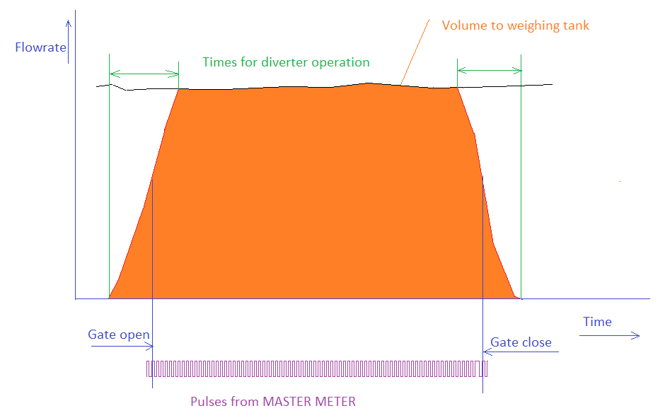

Testing time for method with weighing system (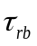) is obtained from the start point of the measurement Gate open and end point of the measurement Gate close.

Time for conventional true value for this method is
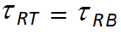 [s] (S1)
The diverting process is measured with sensor and AD converter is evaluating the process and sending values to TBF.

START and END points of the measurement are settable in TBF. These values are transmitted to PROCESS board.

Curve of the diverter transition

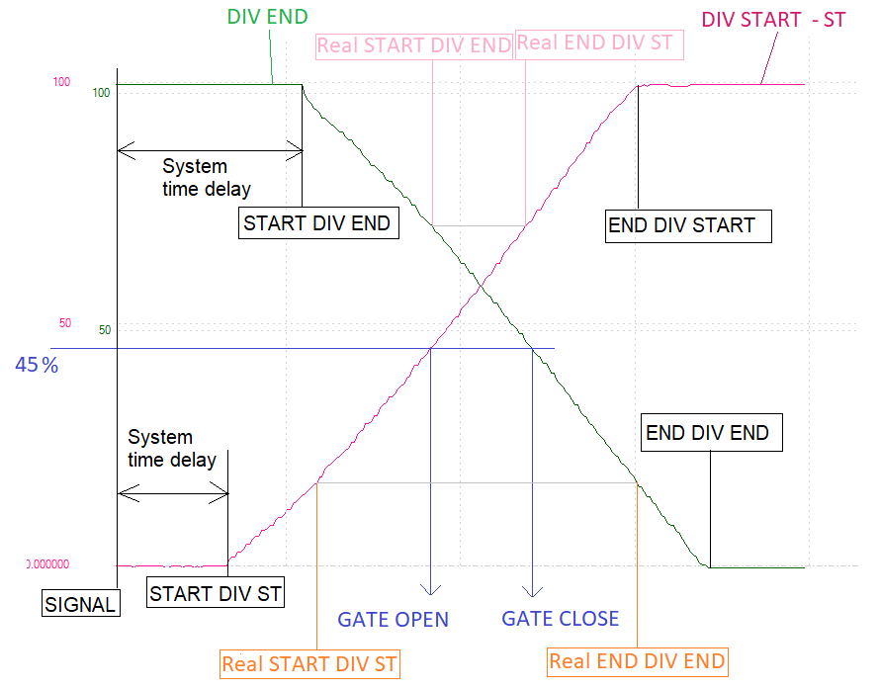

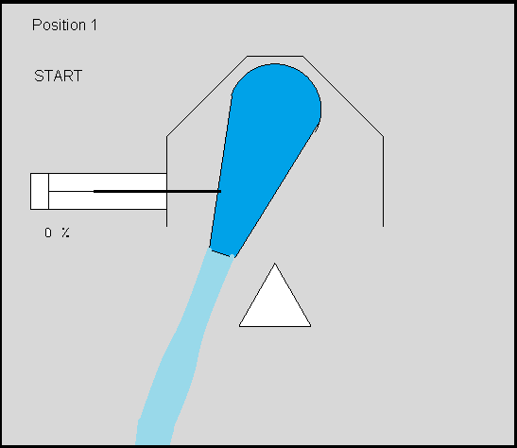
Before using the diverter for measurement, the starting point end point and gate point must be set.
There is a procedure how to set these values for the diverter.
As an example for this diverter, the START point is set 20 % of the transition. The gate opening is set to 45 % and END point is set to 70 %.

Follow the curve DIV START - ST
At the start of the measurement, the diverter start the transition. There is a system delay from the signal to real action of the diverter.

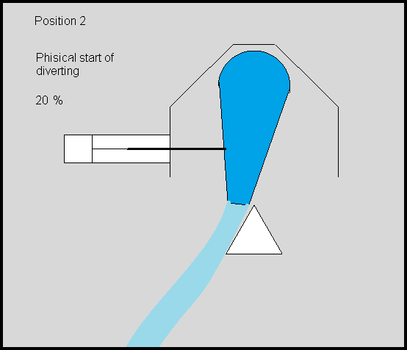
After this delay the position of diverter starting to move. At the first part between START DIV ST and Real Start DIV ST, water still completely flows to the reservoir until reaching Real STAR DIV ST.

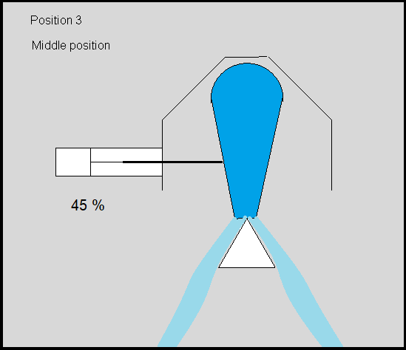
From this point the water start to flow to weighing tank.
When the value reaching 45 % of the transition value, the Prematest board is opening the GATE for counters and time.

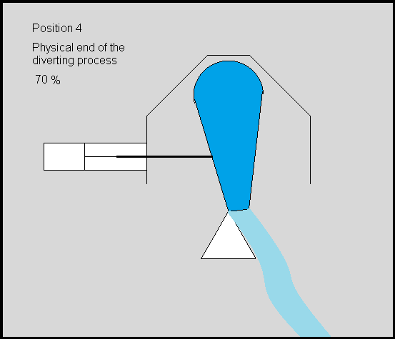
At the point Real END DIV ST the water completely is flowing to the weighing tank.
Value τ_{DI1} is given from Real START DIV ST to Real END DIV ST

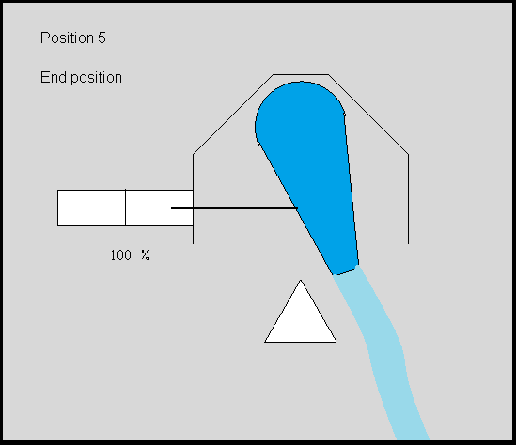
From the point Real END DIV ST to END DIV ST water completely flows to the weighing tank

Follow the curve DIV END
Before end of the measurement the signal is sent to the diverter. Again there is a time delay of the mechanical move. After the delay the diverter start to change the position at the point START DIV END. When reaching certain position (70%) Real STRART DIV END the water start to flow also to reservoir. After reaching the position 45 % the gate will be closed for counters. When reaching point (20%) Real END DIV END water completely is flowing to the reservoir.
Value τ_{DI2} is taken from Real START DIV EN to Real END DIV EN

Master meter method of operation
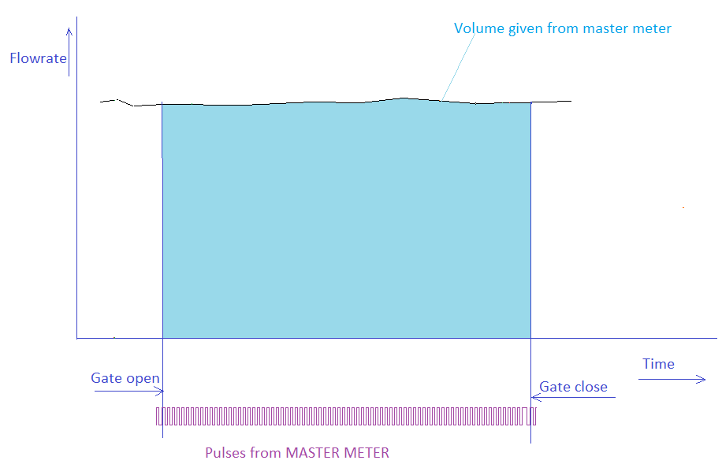

After opening the gate the system will count pulses from master meter. After reaching required volume the Prematest board PTB will end the test by closing the gate. Time for master meter method is

Actual state values
Are values which are logged with TBF during running tests.
Actual state values are
Actual time Time AC Time [h:m:s]
Actual flowrate is also stored Qri AC Q_{riac} [m³/h]
Test time Tau AC τ _{AC} [s]
Pulses actual from reference meter nrac n_{rAC} [-]
Actual volume from reference meter Vrac V_{rAC} [dm³]
Actual temperature at the inlet Temp. UPAC t_{upac} [ ºC]
Actual temperature at the outlet Temp. DWAC t_{dwac} [ ºC]
Actual temperature at the diverter Temp. DIAC t_{diac} [ ºC]
Pressure at the inlet actual Press. UPAC P_{upac} [kPa]
Pressure at the outlet actual Press. DWAC P_{dwac} [kPa]
Pressure difference from Pdiff meter Press. DIAC P_{diac} [kPa]
Actual reading from weighing machine Mass ACB M_{acb} [kg]
Actual ambient temperature Temp. Amb AC T_{amac} [ ºC]
Actual ambient pressure Press. Amb AC P_{amac} [kPa]
Actual ambient humidity Hum. AC Hu _{ac} [ %]
Actual position of the adjusting valve PosV. AC PosV _{ac} [ %]

Time process for standing start and stop:
Testing time is obtained from command for opening the valve

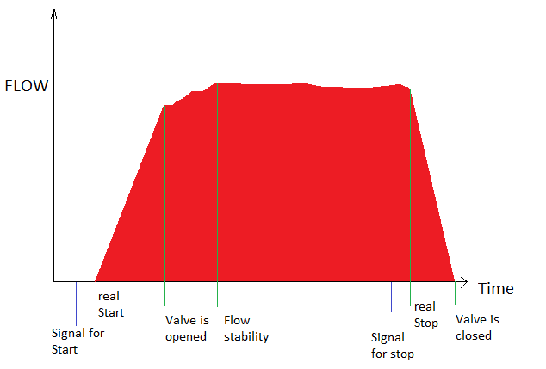
Testing time 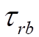 is taken from the signal for start to signal for stop from TBF.

Testing time is calculated from the signal for start and signal for stop.

Because this signal is controlled from TBF and communication between PC and board is 1 s the time for standing start and stop is having readability 1 s.

Opening and closing time for the START and STOP is also measured.
Valve open time 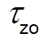 (Start valve open time) is measured and calculated with the board with readability 2 ms. Valves sensors are creating signals and they can be used to measure this time.

Valve close time 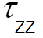 is calculated in the same way as the valve open time.
Flow 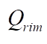is calculated from the– FLOW stability from the previous picture. It means only first 30 % of the test is ignored for flow measurement or at least first four measurement are ignored.

Flying start and stop collection method with weighing machines

a) synchronization using master meter pulses

b) synchronization using time pulses.
This method requires pulse output from tested meter. It can be direct pulse from meter or optical sensor from mechanical counter.
- Synchronization using master mete pulses is perfectly working when number of pulses receiving from the tested meter is higher or equal to 10. For some tested meter this method can work properly receiving only 3 pulses for the test.
- Synchronization using time pulses is perfectly working when number of pulses receiving from tested meter is higher as 30.
Both methods are completely controlled from Prematest board (PTB). TBF is sending information to PTB about the flowrate, volume method and other, and PTB is working independently and autonomously on TBF.
The clock phase of the PTB is 0,1 ms.

State 1
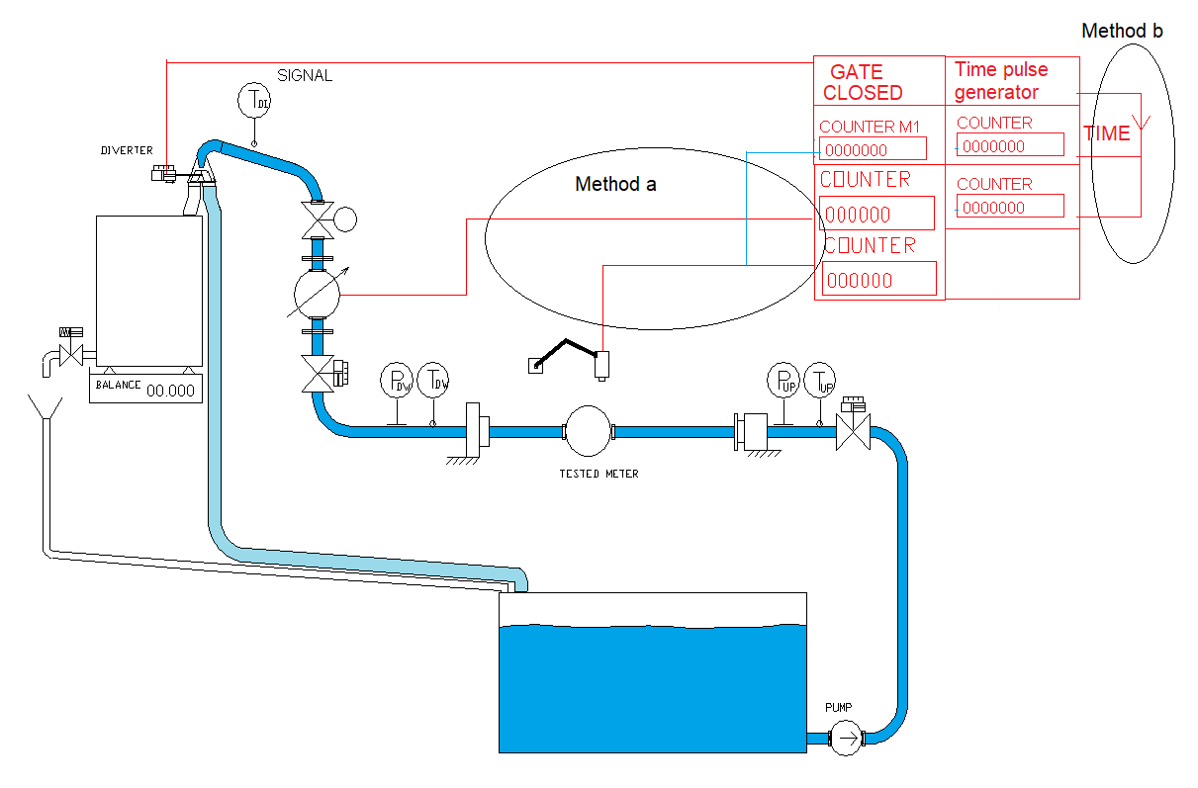
PTB is having counters for pulses for each tested meter, for master meter and also for master meter triggering from each tested meter.
PTB is having counters for pulses for each tested meter, for time pulses triggered form diverter sensor and for time pulses triggered each tested meters.
For both methods
Water is flowing through the testing line to the reservoir.
PTB is adjusting the correct flowrate.
System is checking the actual weight. TBF can provide emptying process if required.
TBF read the value from weighing machine. From weighing process, TBF calculate M_{RSTB}.

After reaching stable flow, TBF can wait until defined time if defined.

State 2
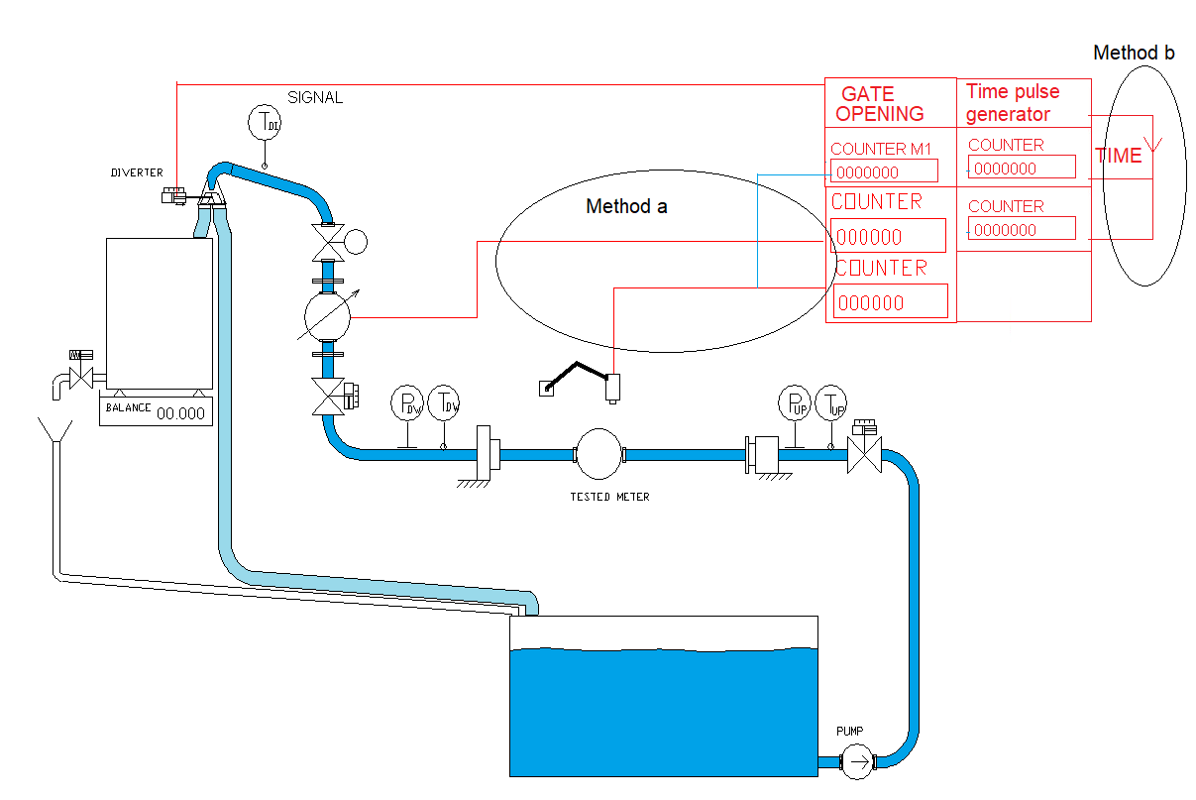

Diverter is switching to the position “Weighing tank”.
- Gate for pulses of the master meter is opening from the diverter sensor.
- Gate for time pulses are opening
Water is flowing to the weighing tank. System is waiting for the first pulse from tested meter.
- Description for method with pulses from master meter
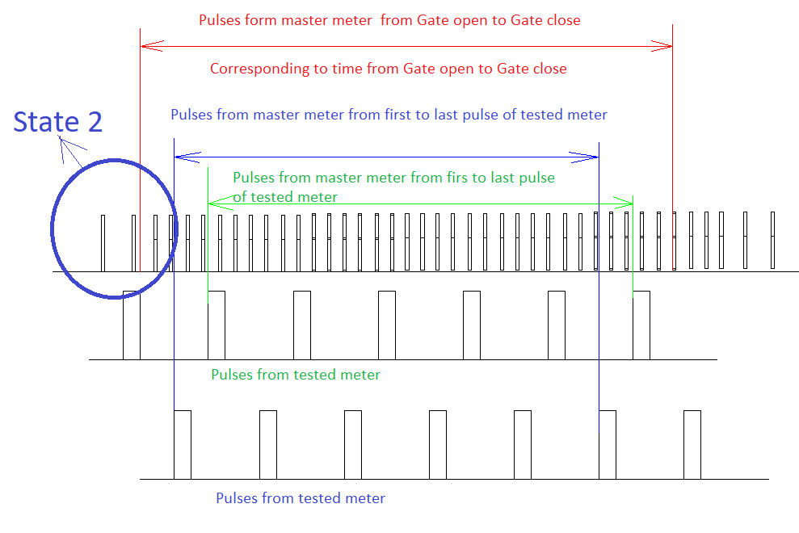
From the start of the measurement, TBF is collecting actual state values. Storing period is 1s.
Actual state values are described in the chapter - actual state values.

These values are stored for further use.

- Description for method with pulses from time generator
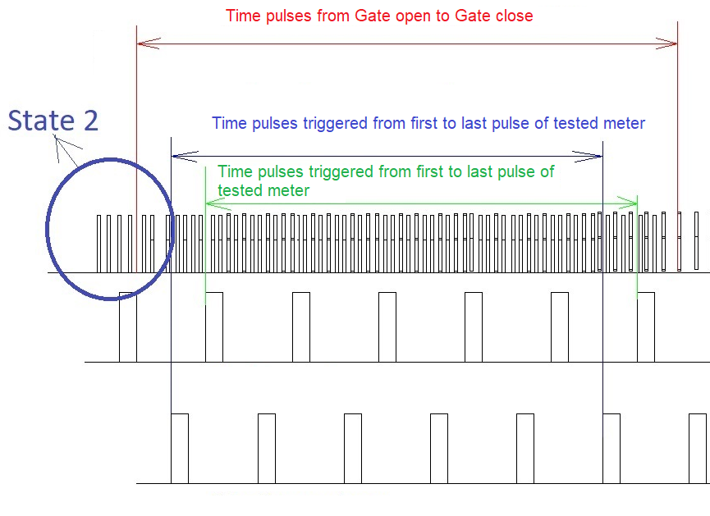

State 3a
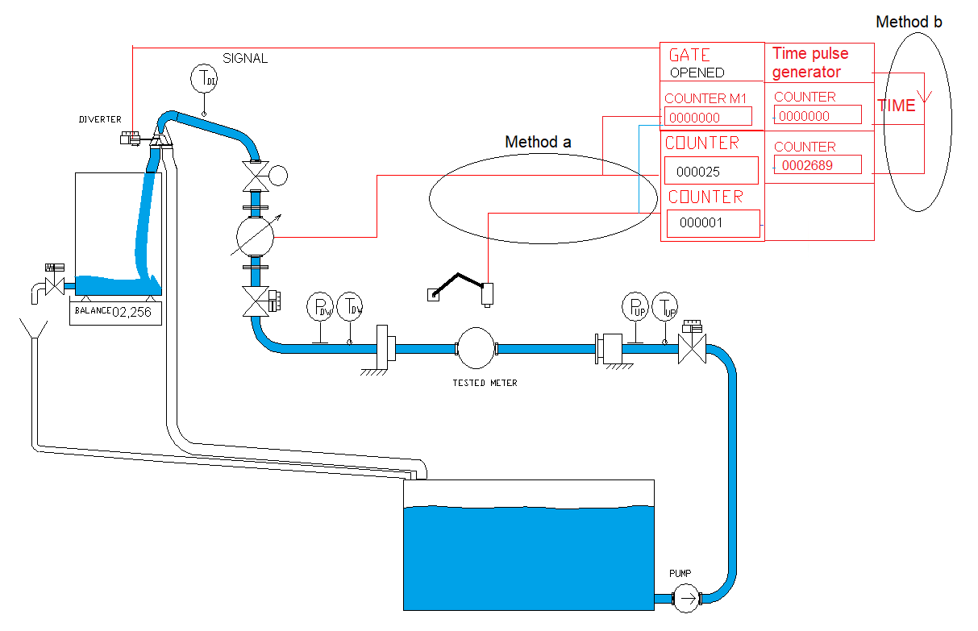
Water is flowing to the weighing tank. First pulse from tested meter is opening the gate for the additional counter for master meter for method a and for time for method b.

- Method using pulses from master meter

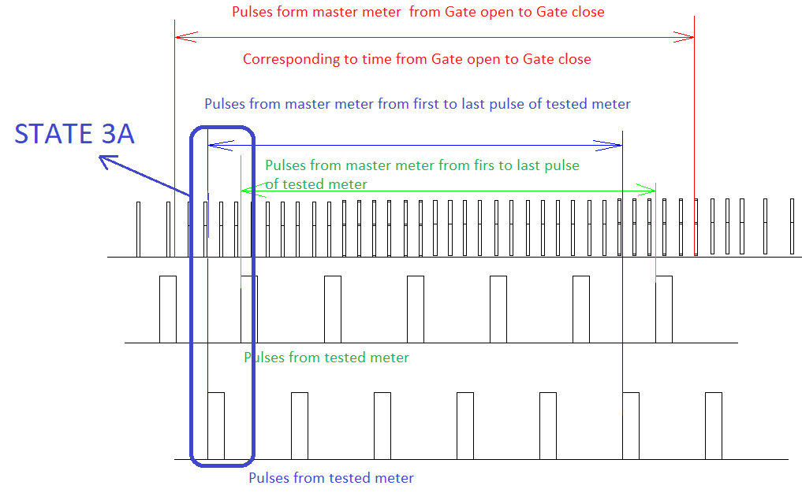

- Method using pulses from time pulses
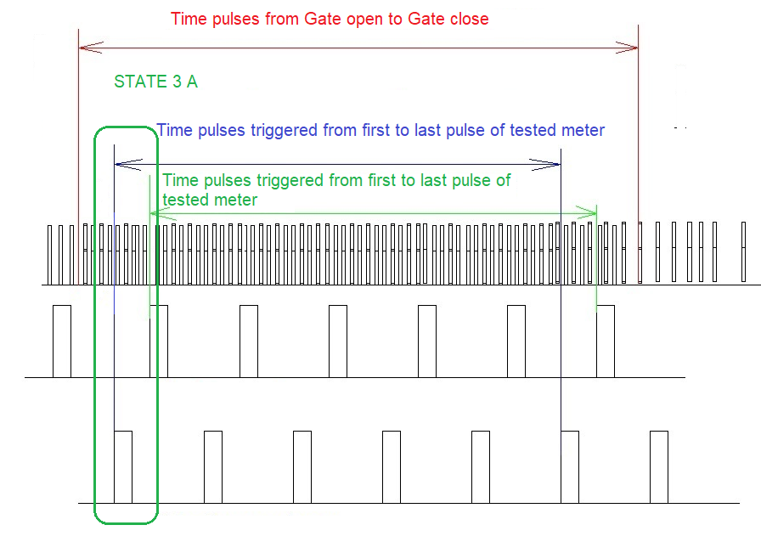

State 3b
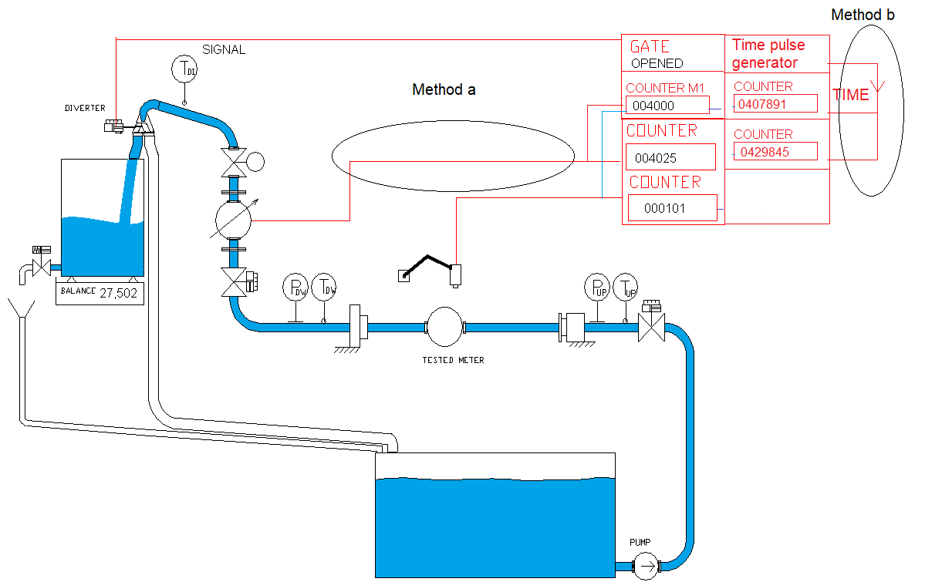
PTB is counting pulses from Master meter, tested meter and additional master meter pulses from the first coming pulse. State values are stored in TBF.

- Method using pulses from master meter

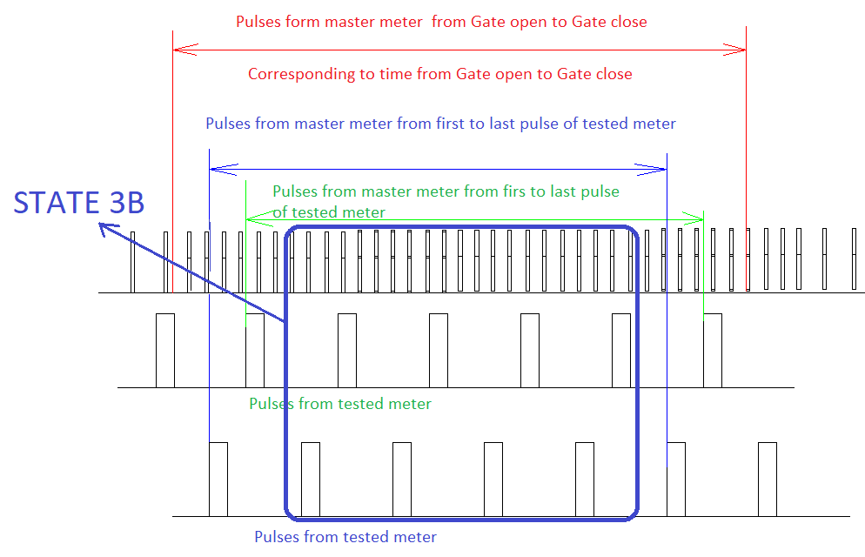

- Method using pulses from time pulses
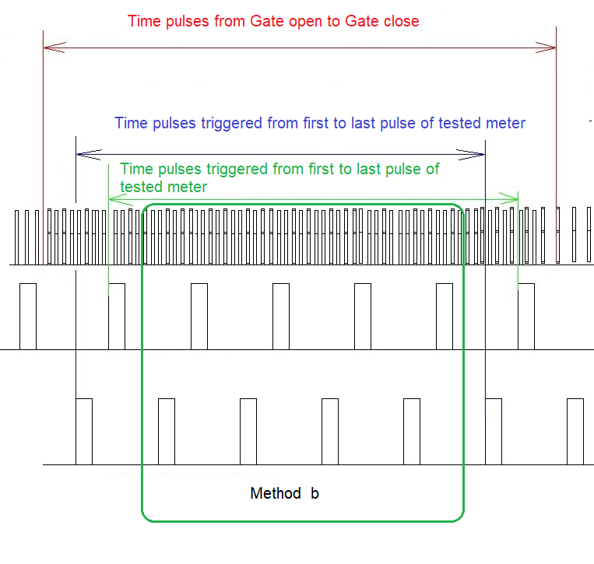

State 3c
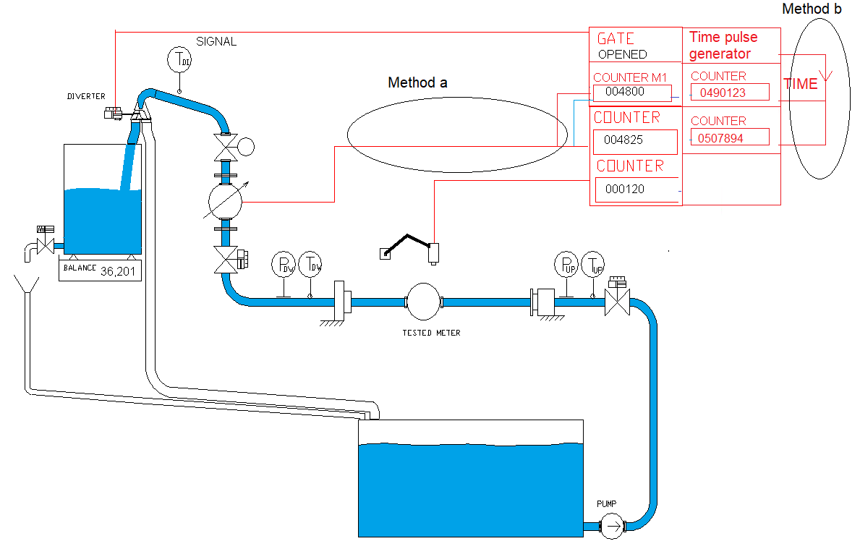
The last pulse from the tested meter (before diverter is switching back) is the gate for the additional pulse counter from the master meter for method a and for time pulses for method b.

- Method using pulses from master meter

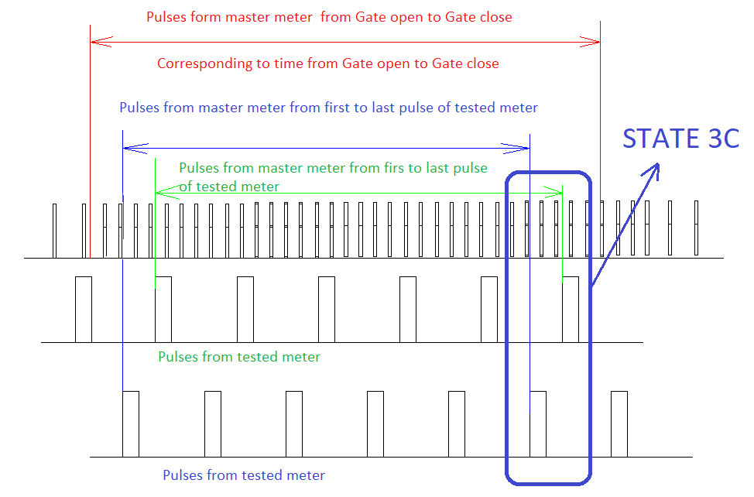

- Method using pulses form time generator
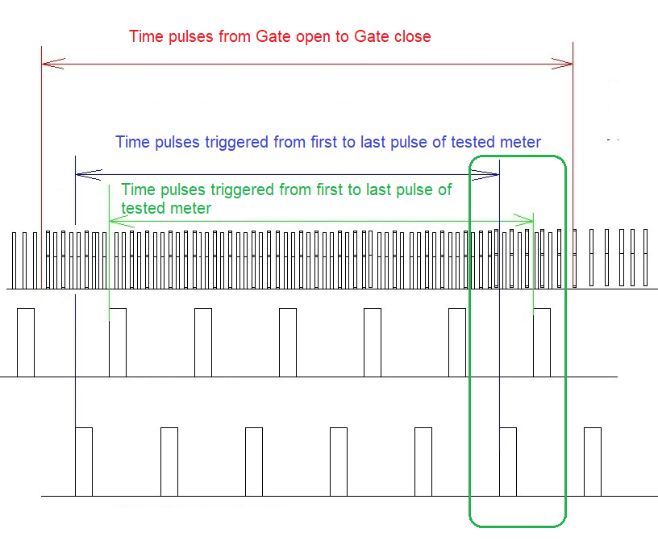

State 4
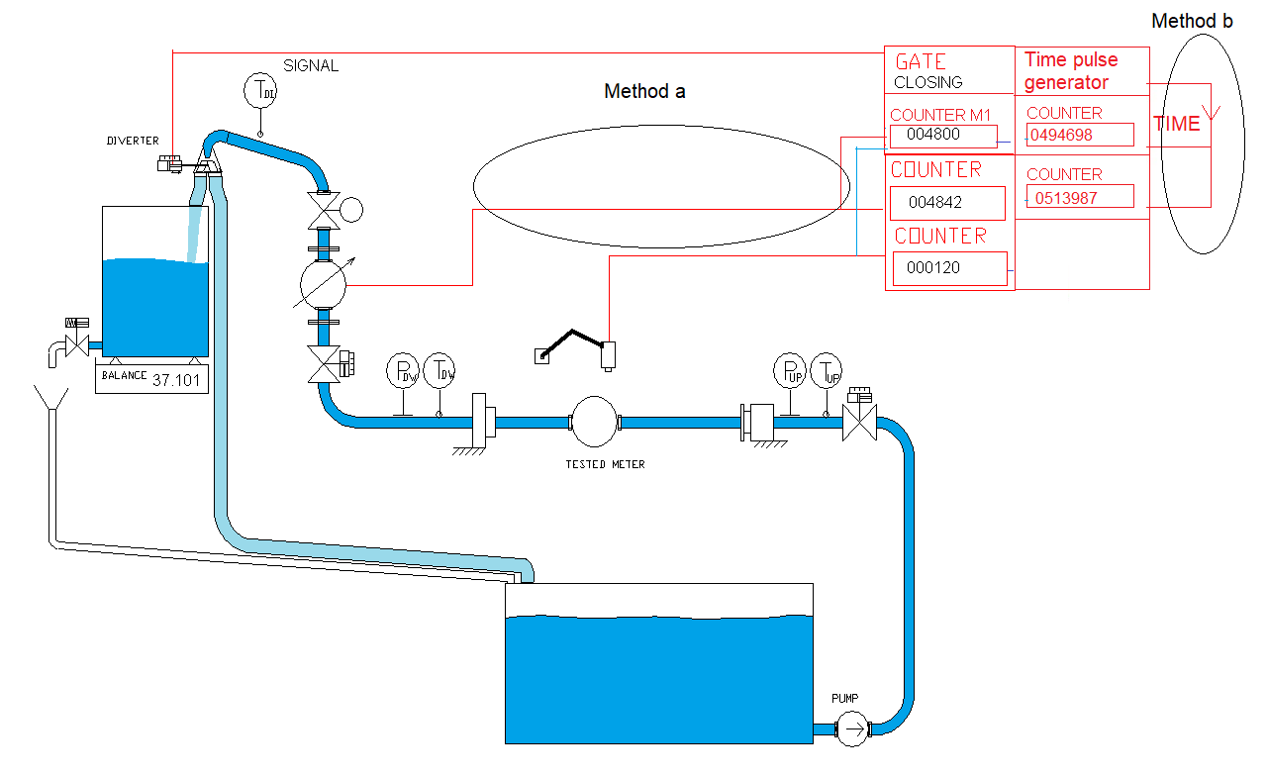
End for master meter calibration. Diverter is changing its position to “reservoir”. Signal from diverter is the end signal for master meter calibration and test time.

- Method using pulses from master meter
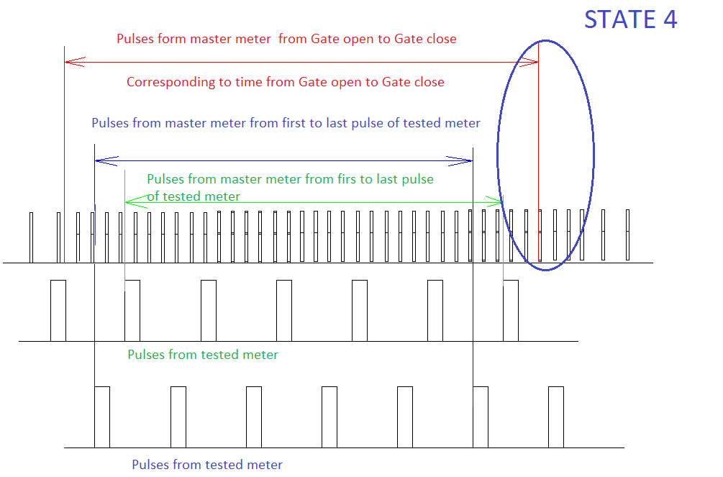

End for master meter calibration. Diverter is changing its position to “reservoir”.
- Method using pulses time generator
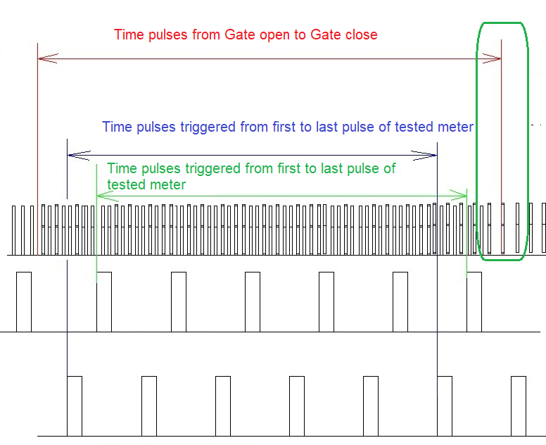

State 5
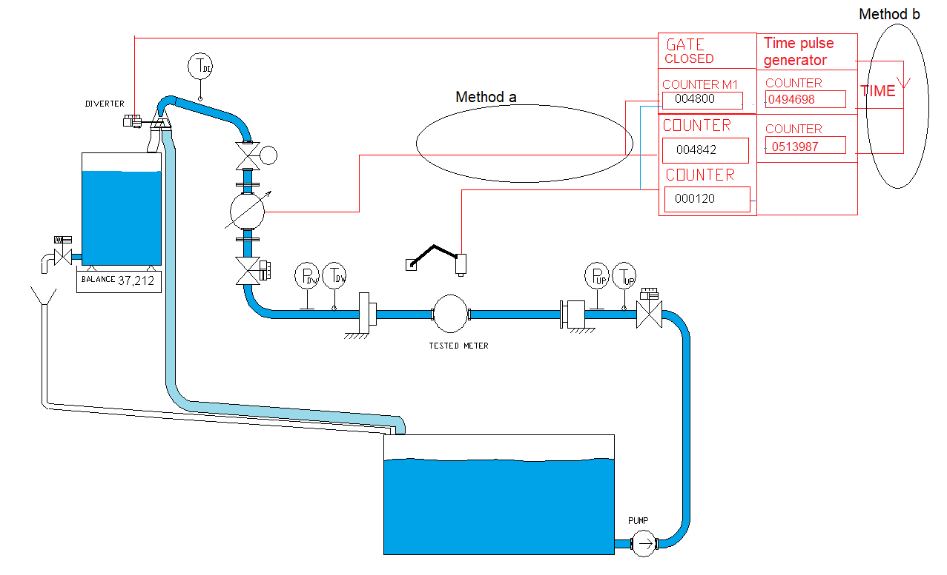
TBF is collecting all data from PTB and from the balances. The correct value for each tested meter is different due to different number of
- pulses obtained from master meter corresponding to tested meter. System is calculating the master meter error.
- Pulses obtained from time generator corresponding to tested meter.

TBF is receiving following information
- From PTB - n_{r} [-] and τ_{rt} [s] for reference meter, n_{m} [-] and n_{rm} [-] for each tested meter
- From PTB n_{m} [-], τ_{m} [s] for each tested meter.

From both methods - from weighing system, M_{RENB} [kg]
For each meter the TBF is calculating volume according to formulas (V16), (V17) and (V18)
Where 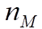 is received from the board and represent number of whole pulses coming from certain meter.
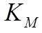 is specific constant of the tested meter – pulses / liter and it is in the memory of TBF and is tied to measuring procedure.

Each meter is having different correct volume, which was received from the conventional true value from the weighing method multiplied by corrections
For method a) C_{MMP} using formula (A6).

For method b) C_{TGP} using formula (A7).

For flying start and stop, both methods are evaluated.
Primary method is with master meter pulses and secondary method is with time generator pulses.

Flying start and stop collection method with weighing machines prolonged, synchronization using master meter pulses
This method requires pulse output from tested meter. It can be direct pulse from meter or optical sensor from mechanical counter. The main reason to use this method is the for some types of meters the testing time must be longer as the capacity of weighing tank.
Method is completely controlled from Prematest board (PTB). TBF is sending information to PTB about the flowrate, volume method and other, and PTB is working independently and autonomously on TBF.
The clock phase of the PTB is 0,1 ms.

State 1
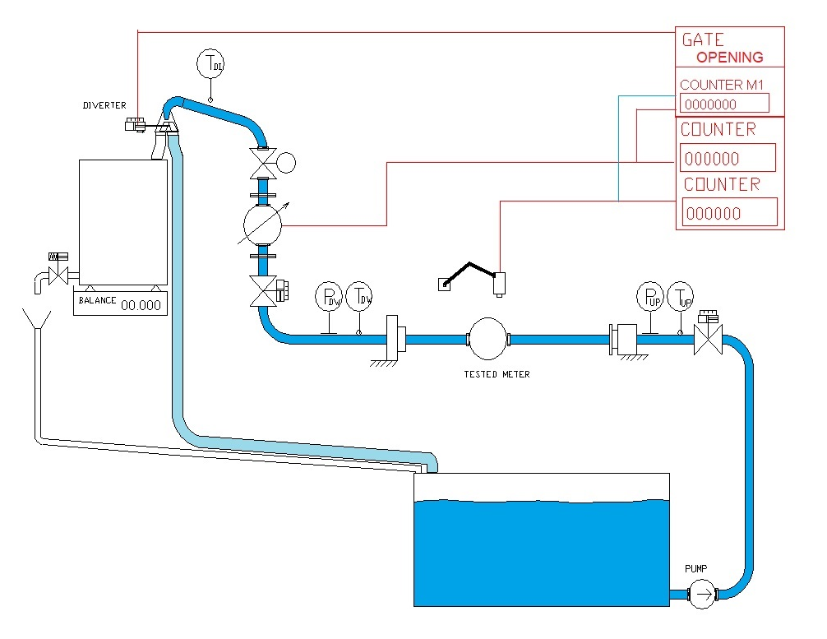
PTB is having counters for pulses for each tested meter, for master meter and also for master meter triggering from each tested meter.
PTB is having counters for pulses for each tested meter, for time pulses triggered form diverter sensor and for time pulses triggered each tested meters.
Water is flowing through the testing line to the reservoir.
PTB is adjusting the correct flowrate.
System is checking the actual weight. TBF can provide emptying process if required.
TBF read the value from weighing machine. From weighing process, TBF calculate M_{RSTB}.

After reaching stable flow, TBF can wait until defined time if defined.

State 2
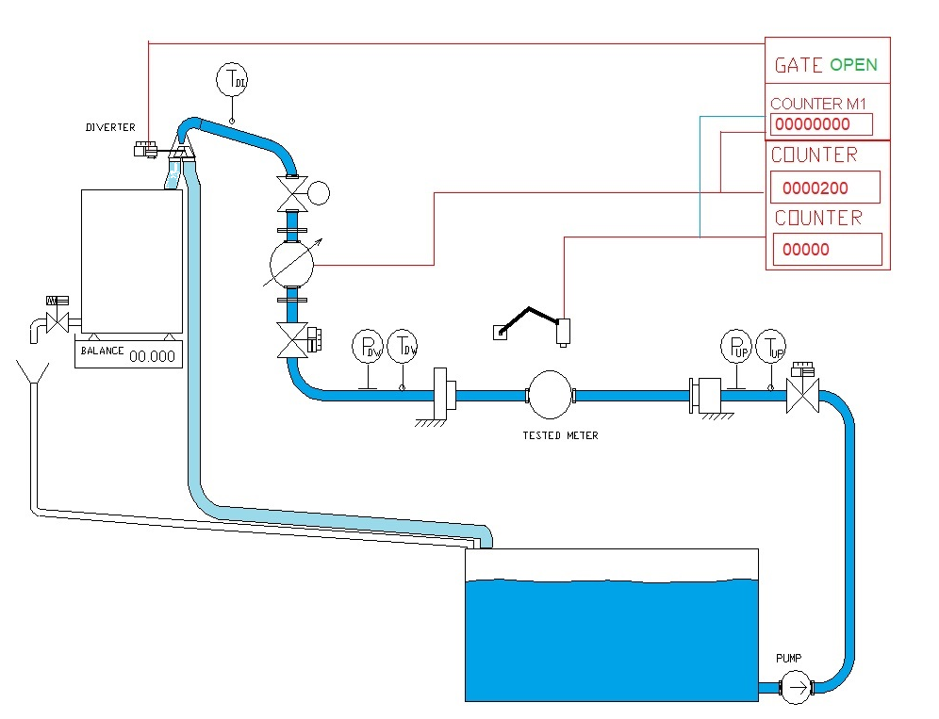

Diverter is switching to the position “Weighing tank”. Gate for pulses of the master meter is opening from the diverter sensor. Gate for time pulses are opening
Water is flowing to the weighing tank. System is waiting for the first pulse from tested meter.
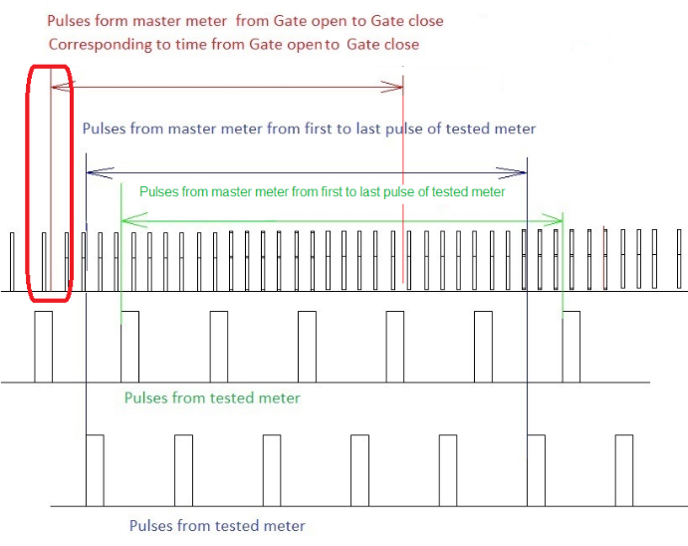
From the start of the measurement, TBF is collecting actual state values. Storing period is 1s.
Actual state values are described in the chapter - actual state values.

These values are stored for further use.

State 3a
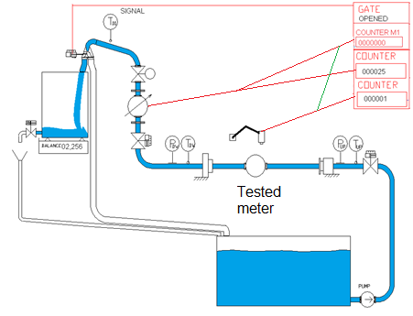
Firs pulse from tested meter is opening gate for master meter second counter

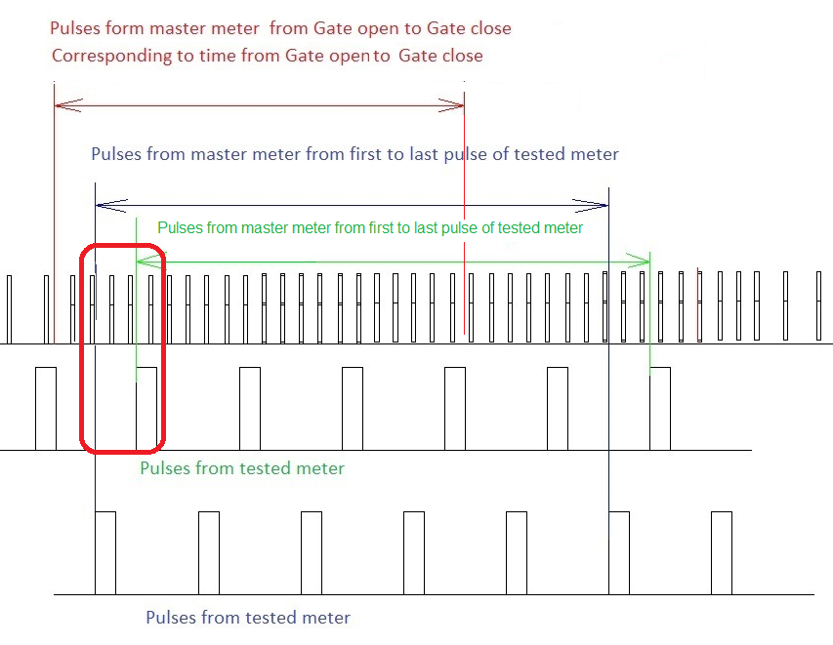

State 3b
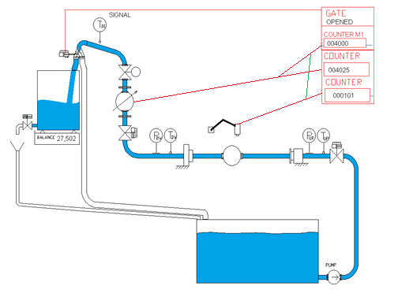
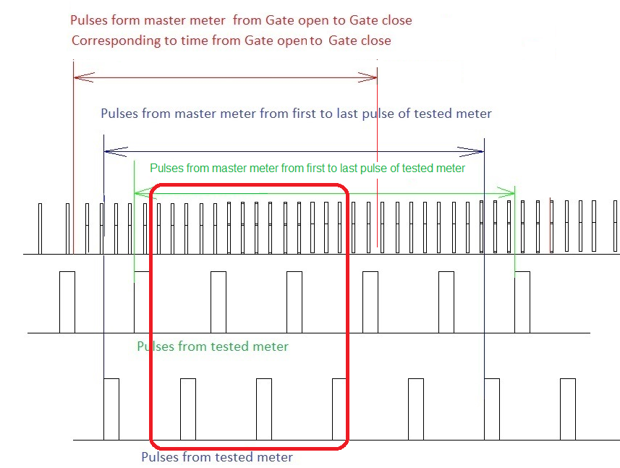

State 4
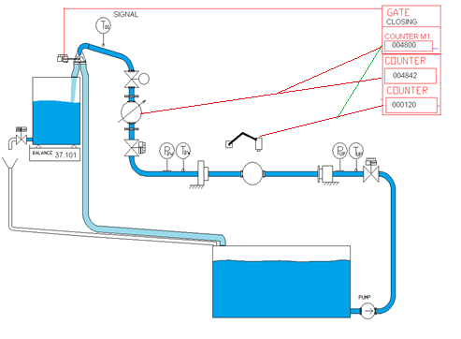
End for master meter calibration. Diverter is changing its position to “reservoir”. Signal from diverter is the end signal for master meter calibration and for pulses n_{R} and test time τ_{RB}.

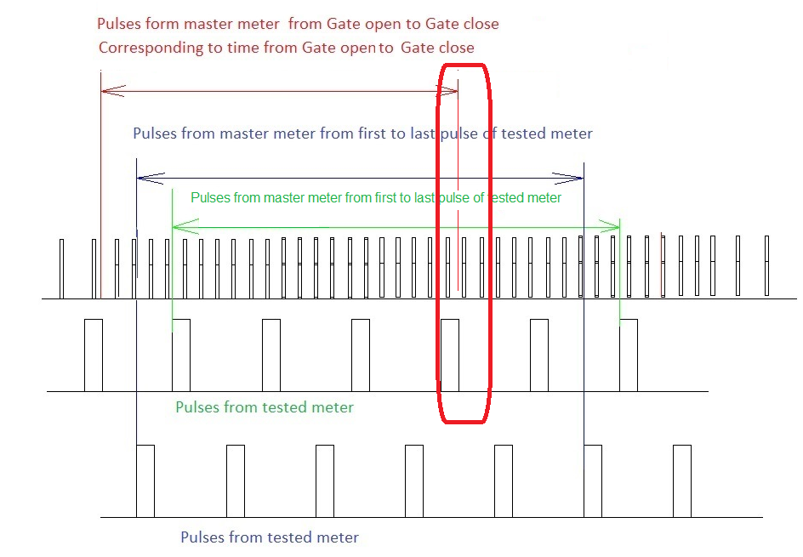

State 5
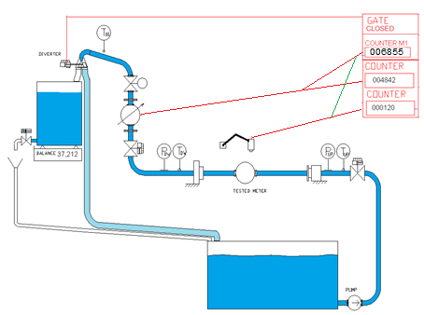
Test is running further until reaching the required volume.
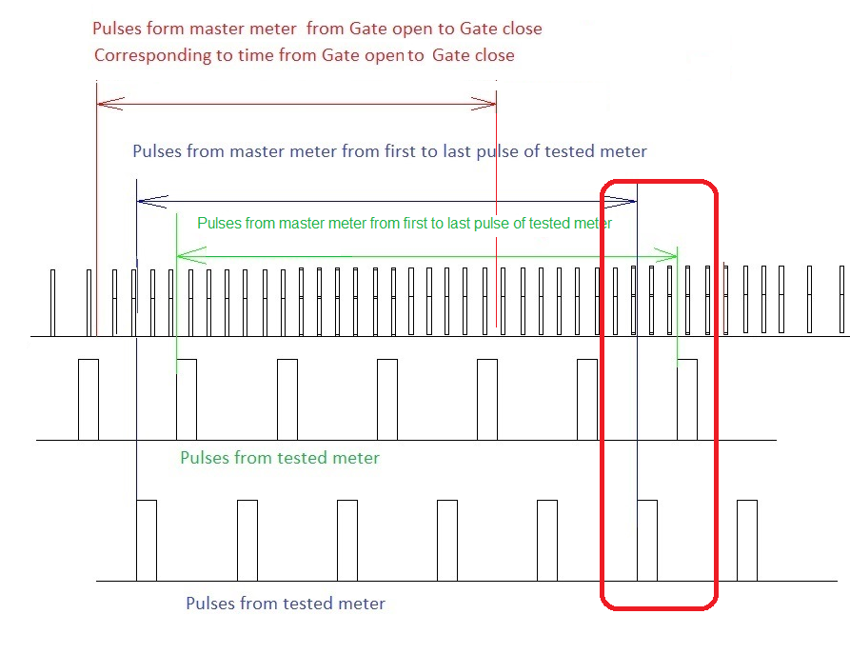
After finishing the test, TBF is collecting all data from PTB and from the balances. The correct value for each tested meter is different due to different number of pulses obtained from master meter corresponding to tested meter. System is calculating the master meter error.

TBF is receiving following information From PTB - n_{R} [-] and τ_{RT} [s] for reference meter, n_{m} [-] and n_{RM} [-] for each tested meter and also τ_{m} [s] for each tested meter and from weighing system, M_{RENB} [kg]

For each meter the TBF is calculating volume according to formulas (V16), (V17) and (V18). Each meter is having different correct volumes, which was received from the conventional true value from the weighing method multiplied by corrections.

Flying start and stop collection method with data-stream connection.

This method requires continuous data stream output from tested meter. Tested meter must have capability to send information about the actual volume and corresponding time. The readability of volume and time must be good enough for evaluation of the meter error. Meter must be able to send this information at least 1 times per 5 s.
The conventional true volume and the related reference time for this method are receiving from Premetest board (PTB). The PTB is sending related information to TBF one times per s. Tested meter is transmitting directly information to PC using TBF.

State 1
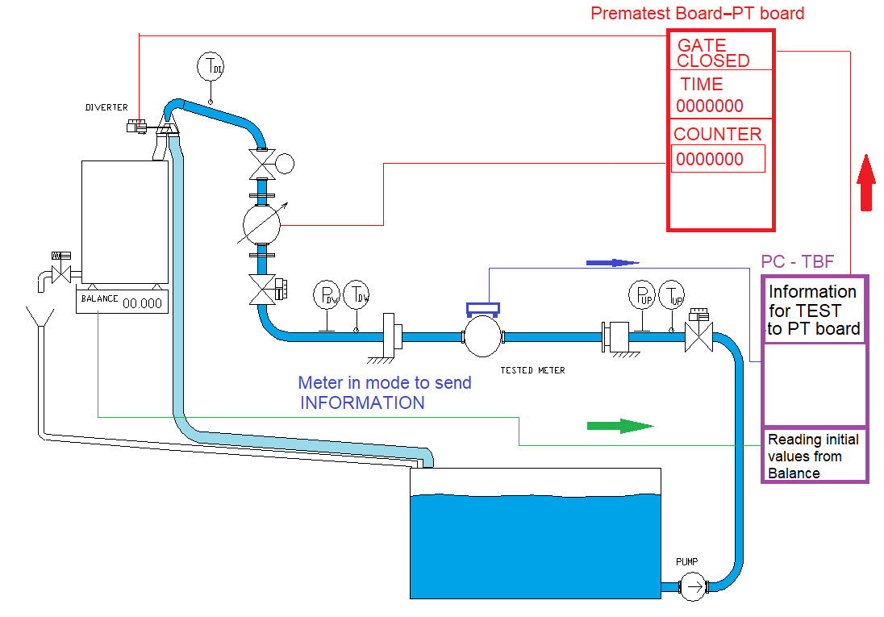
State 1: Water is flowing through the testing line to the reservoir.
System is adjusting the correct flowrate.
System is reading the actual weight. In the case of not enough mass, TBF is emptying the weighing tank.
TBF is reading the weighing machine information according to defined reading process and calculate the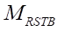.
TBF is waiting until defined time.

State 2
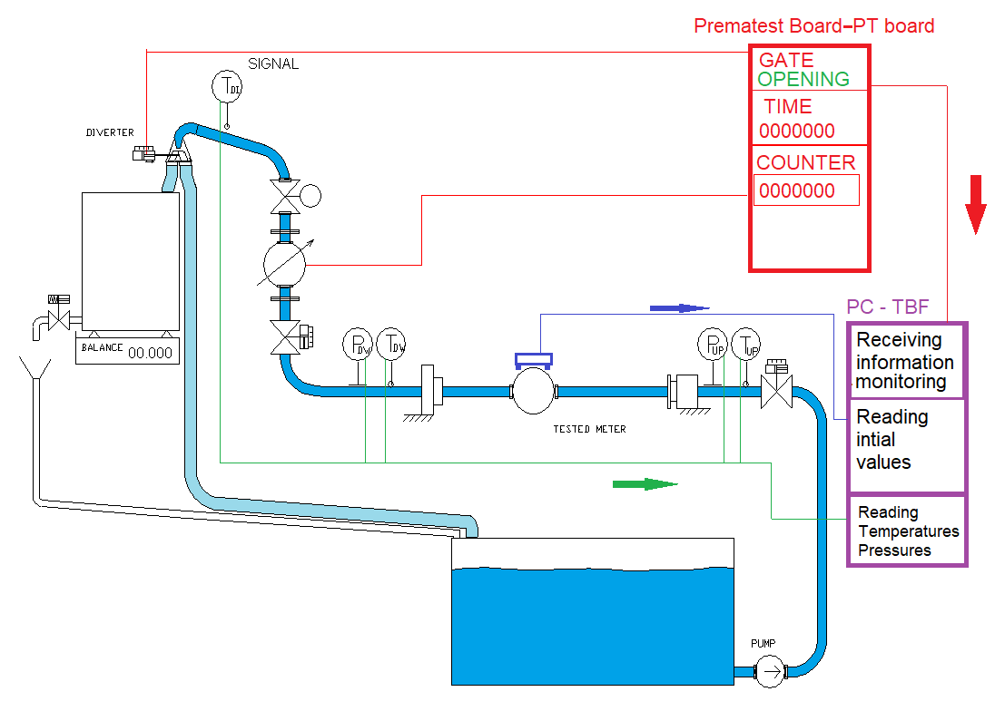
Diverter is switching to the position “Weighing tank”. Gate for pulse counter of the master meter is opening, also gate for testing time is opening. TBF is reading initial value from tested meter. Values are actual volume and time. TBF is starting to collect actual state values described in the chapter “Actual state values”
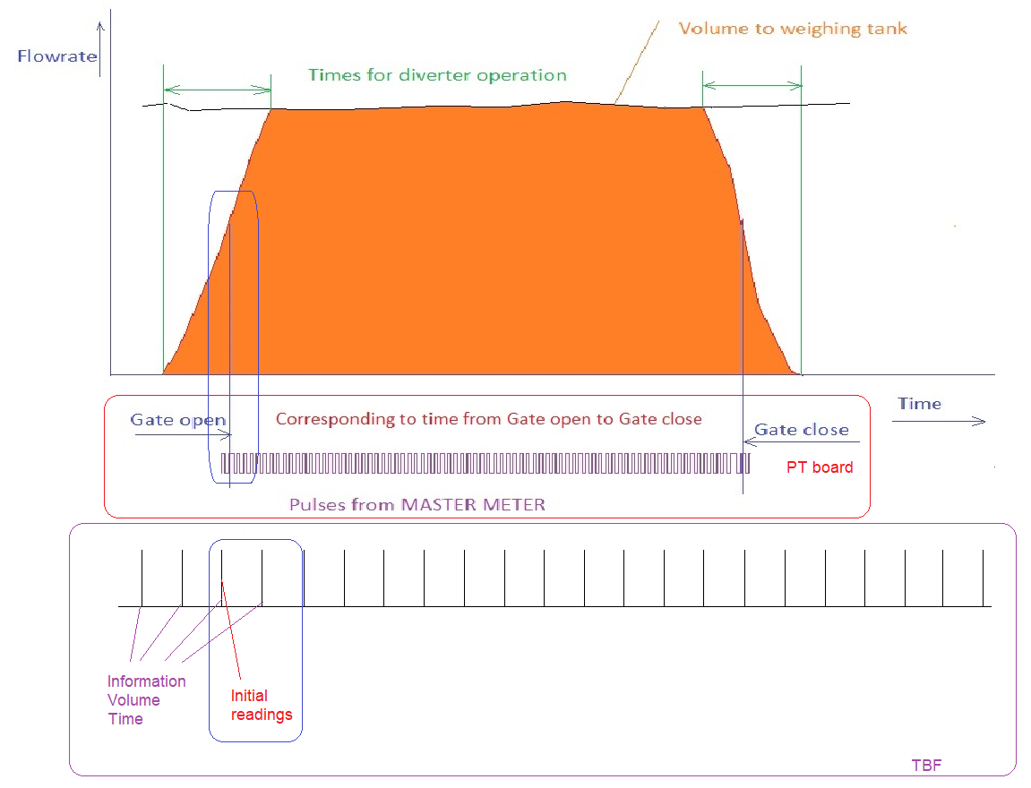

State 3
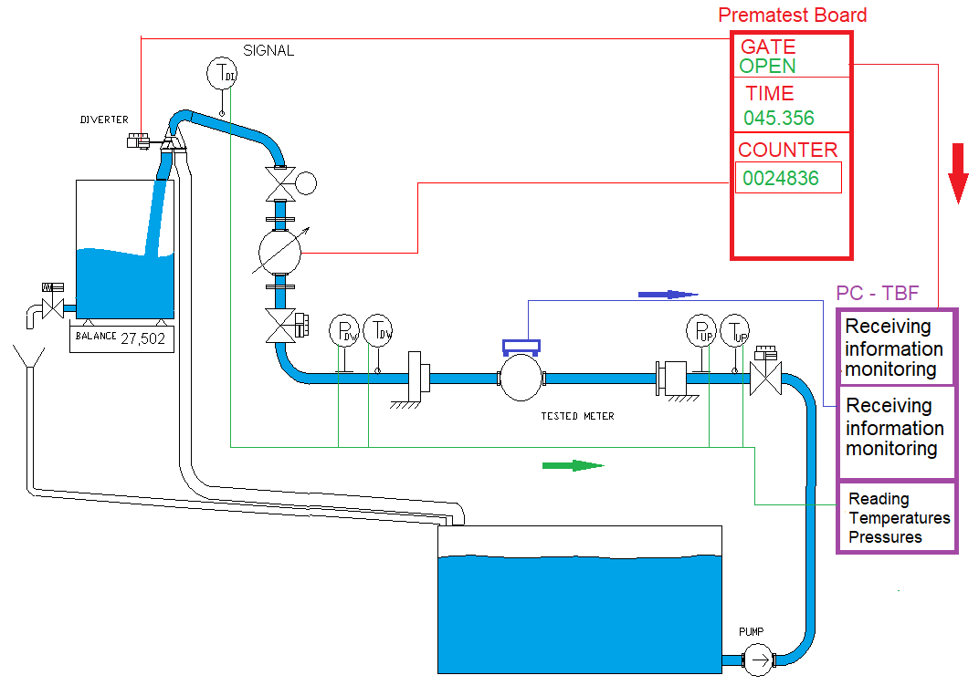

Water is flowing to the weighing tank. TBF is monitoring the process and reading actual state values and also readings from meters.
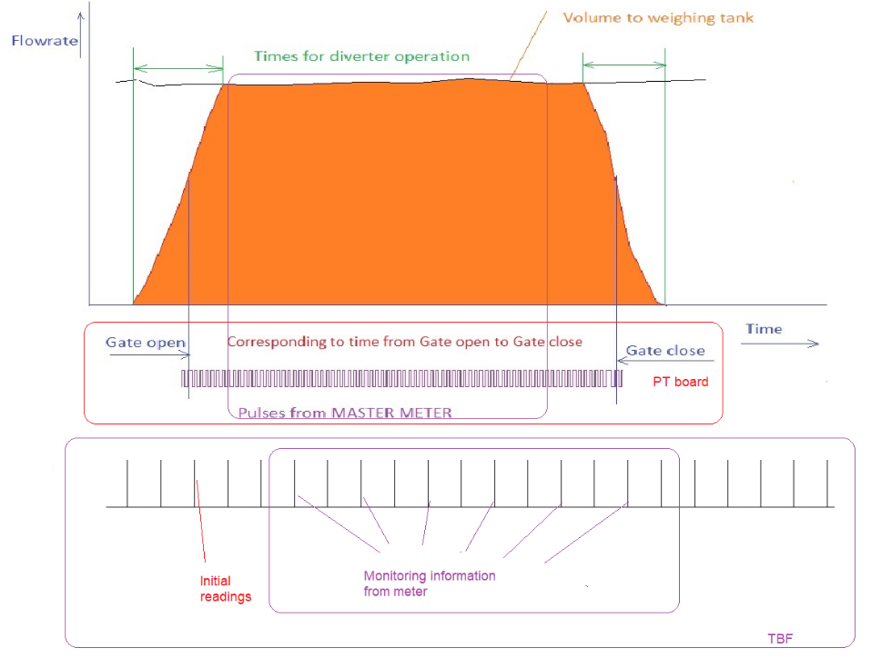

State 4
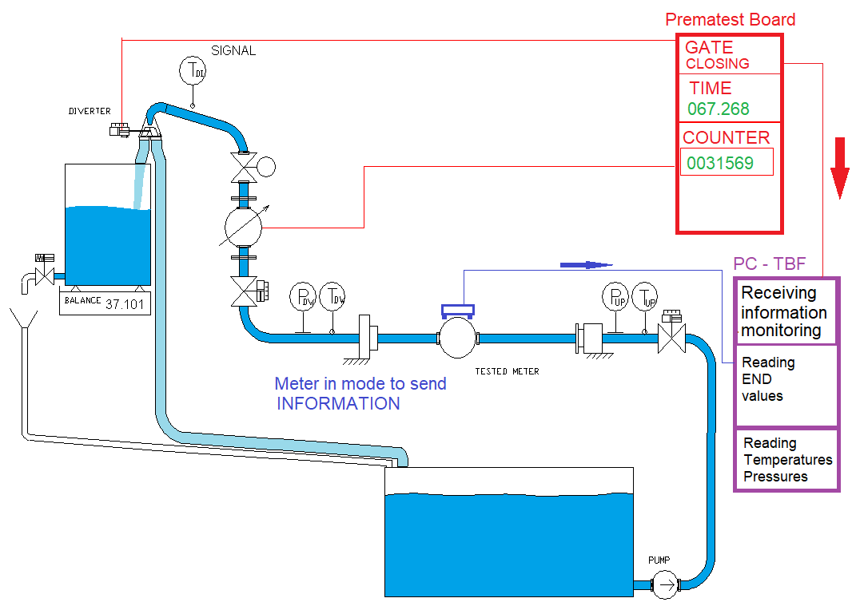

End of test for conventional true value. Diverter is changing its position to “reservoir”. Signal from diverter is closing the gate for pulses and time. TBF is reading end values from tested meter.
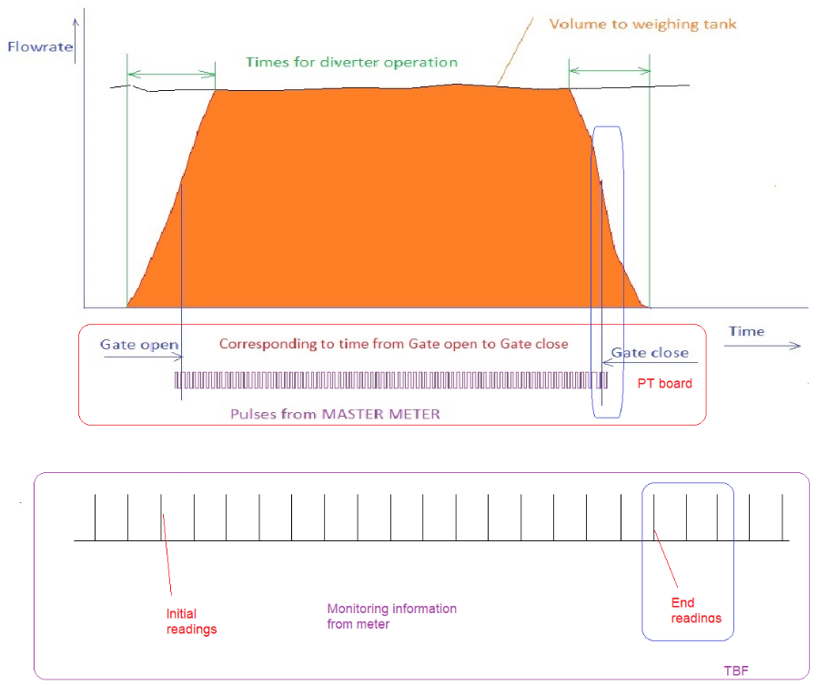

State 5
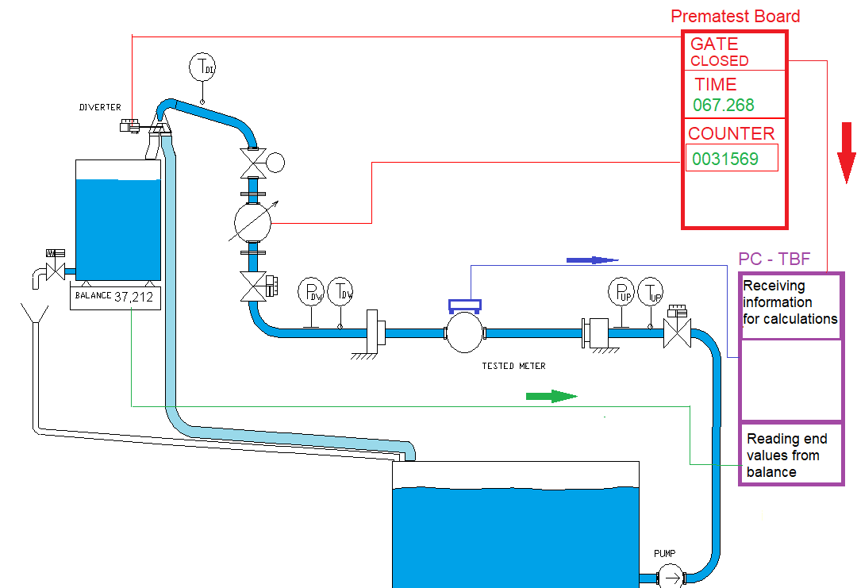

TBD is collecting all required data from PTB and reading values form balances. The conventional true value for each tested meter is different due to different time of incoming readings. System is calculating conventional true value of the system, volume from each tested meter and correct volumes from each meter.
TBF is receiving following information
From PTB - n_{r}[-] and τ_{rt}[s] ,
From tested meters, V_{mdEN} [dm³], and τ_{mdEN}[s]
From Balance , M_{RENB} [kg]

For each meter the TBF is calculating volume using formulas (V7), (V8) (V9)

Where 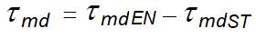[s] (D1)

Flying start and stop collection weighing method, prolonged with data-stream connection.

Requirements for the teste meter is same as for standard weighing method with data-stream connection.
The conventional true volume and the related reference time for this method are receiving from Premetest board (PTB). The PTB is sending related information to TBF one times per s. Tested meter is transmitting directly information to PC using TBF.

State 1
State 1: Water is flowing through the testing line to the reservoir.
System is adjusting the correct flowrate.
System is reading the actual weight. In the case of not enough mass, TBF is emptying the weighing tank.
TBF is reading the weighing machine information according to defined reading process and calculate the. Master meter is having two counters. For this method we have two testing times τ_{RB} and τ_{RT} .
TBF is waiting until defined time.
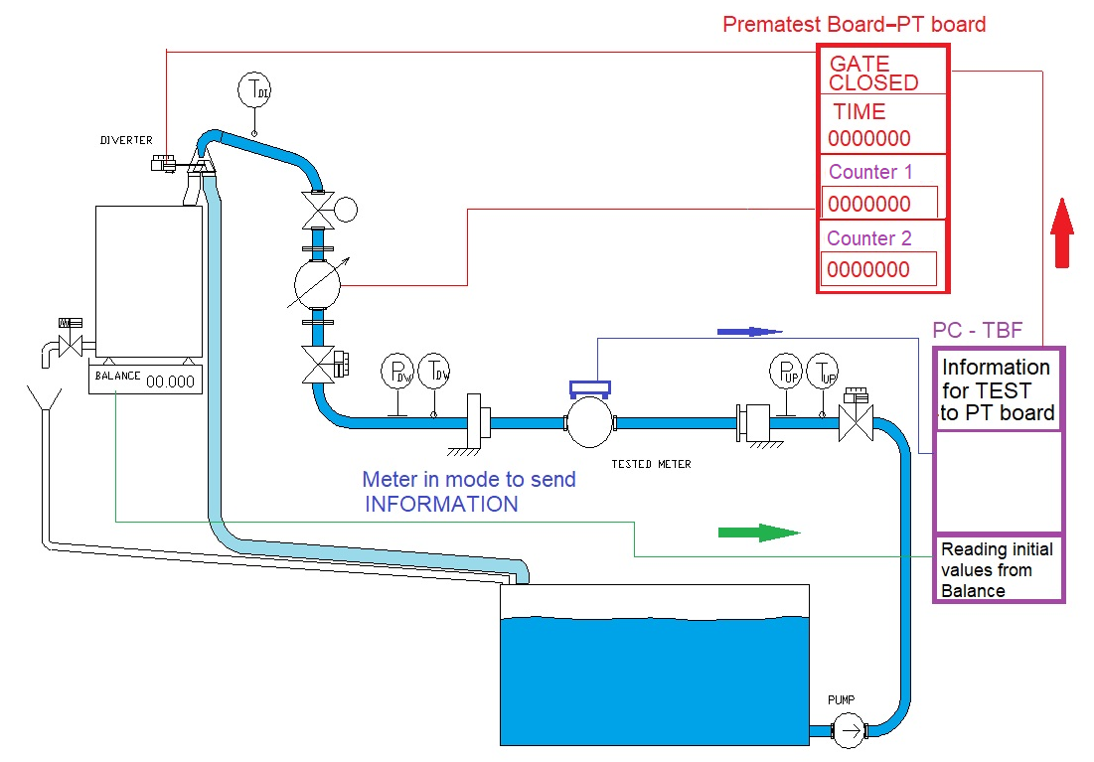

State 2
Diverter is switching to the position “Weighing tank”. Gate for both pulse counters of the master meter is opening, also gate for both testing times is opening. TBF is reading initial value from tested meter. Values are actual volume and time. TBF is starting to collect actual state values described in the chapter “Actual state values”
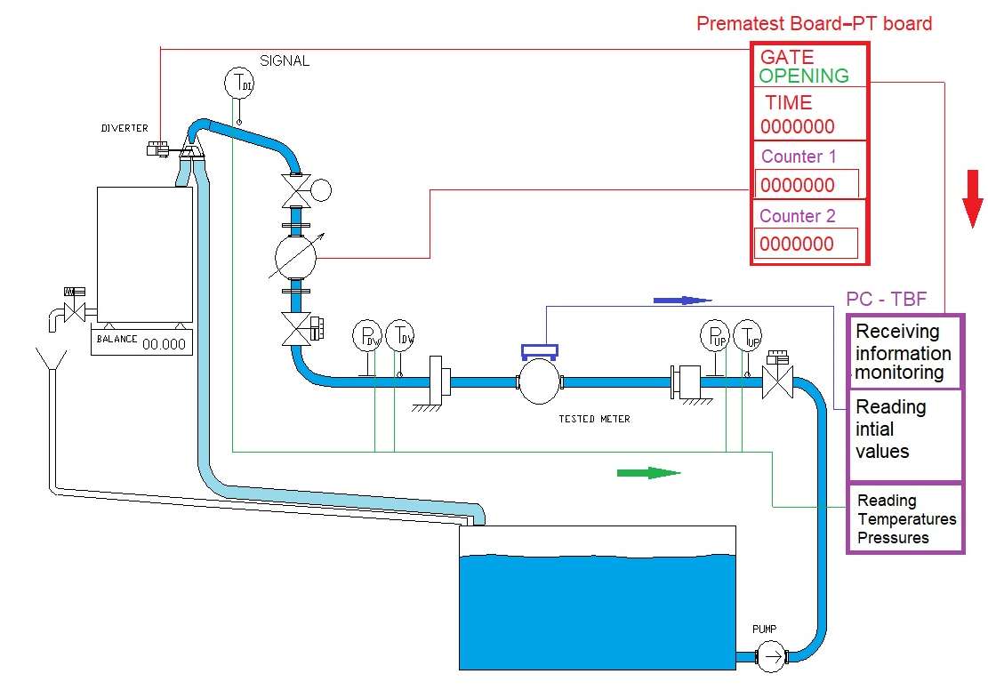
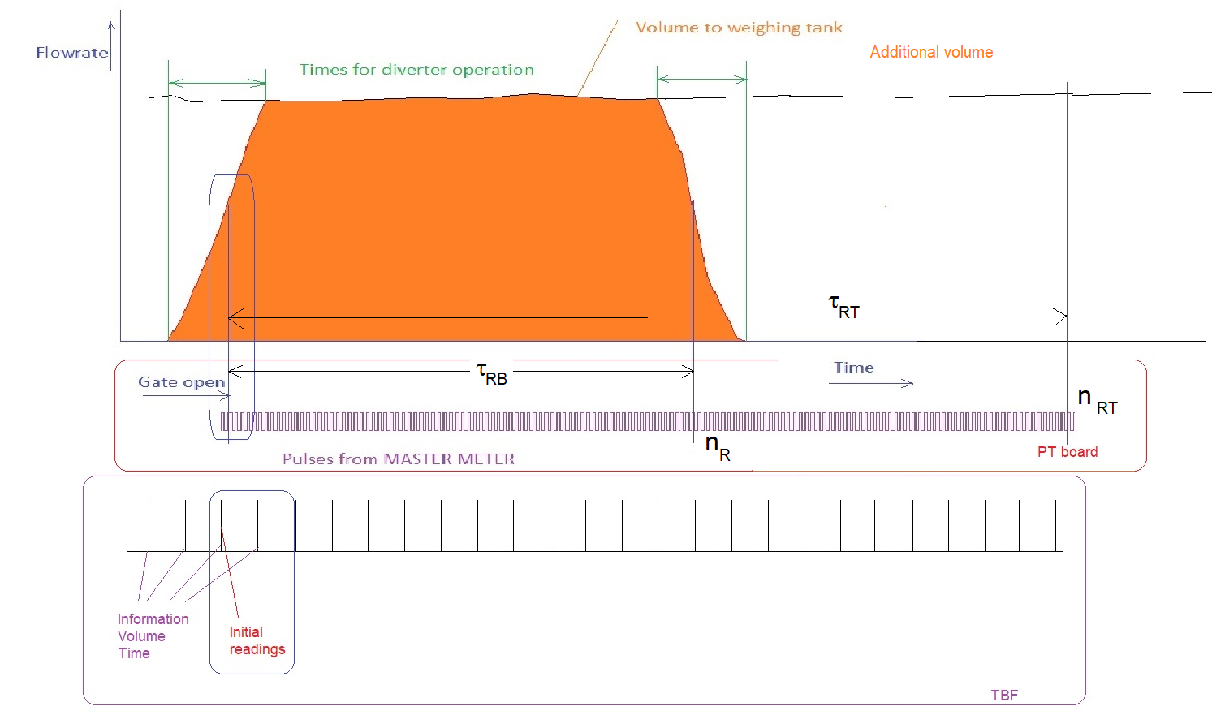

State 3
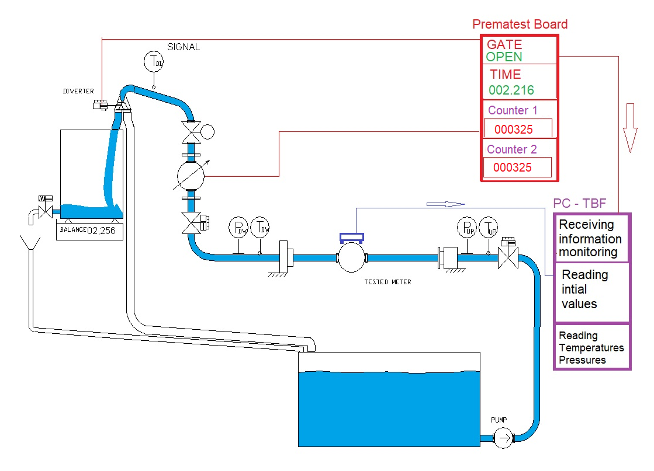

Water is flowing to the weighing tank. TBF is monitoring the process and reading actual state values. TBF is also read values from tested meters.
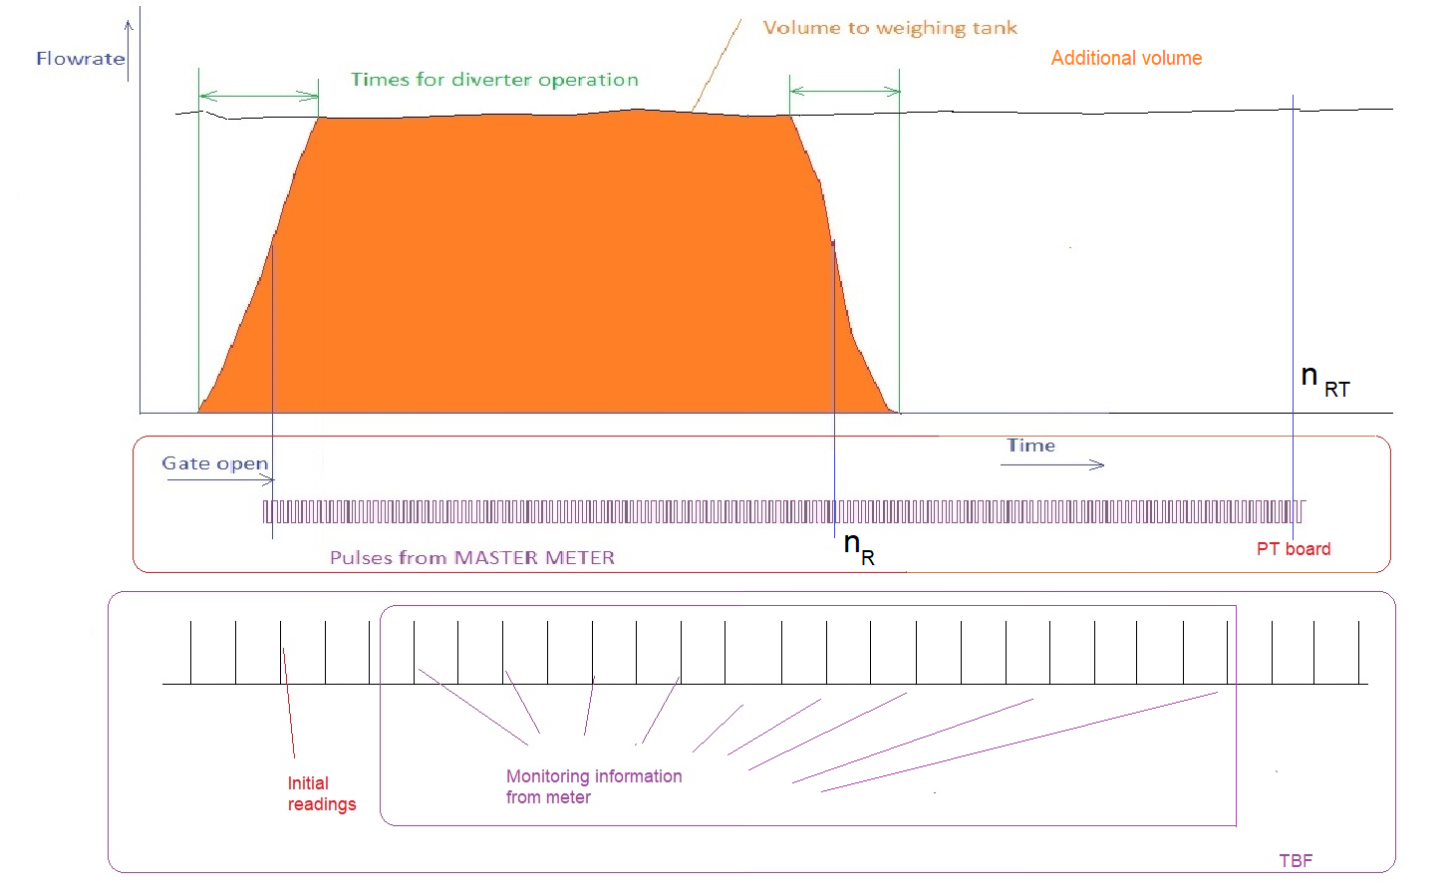

State 4
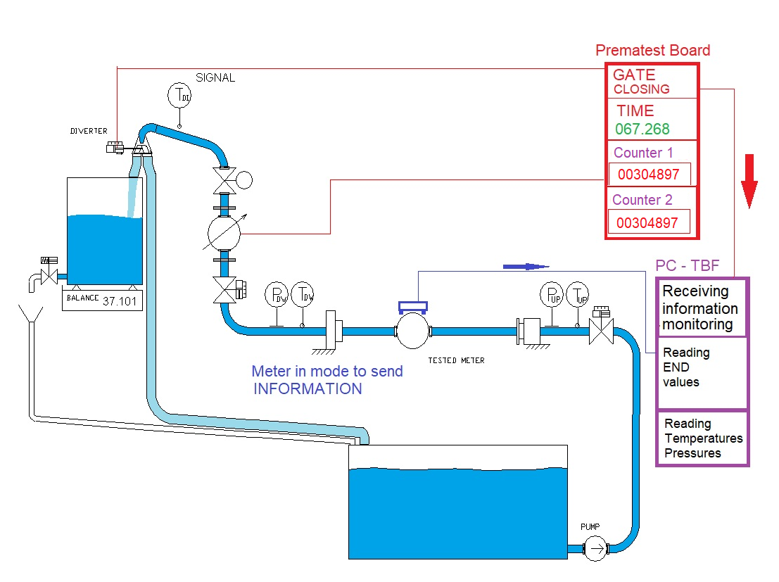

End of test for weighing method of operation. Diverter is changing its position to “reservoir”. Signal from diverter is closing the gate for one pulse counter for n_{R} and one time counter for τ_{RB} .
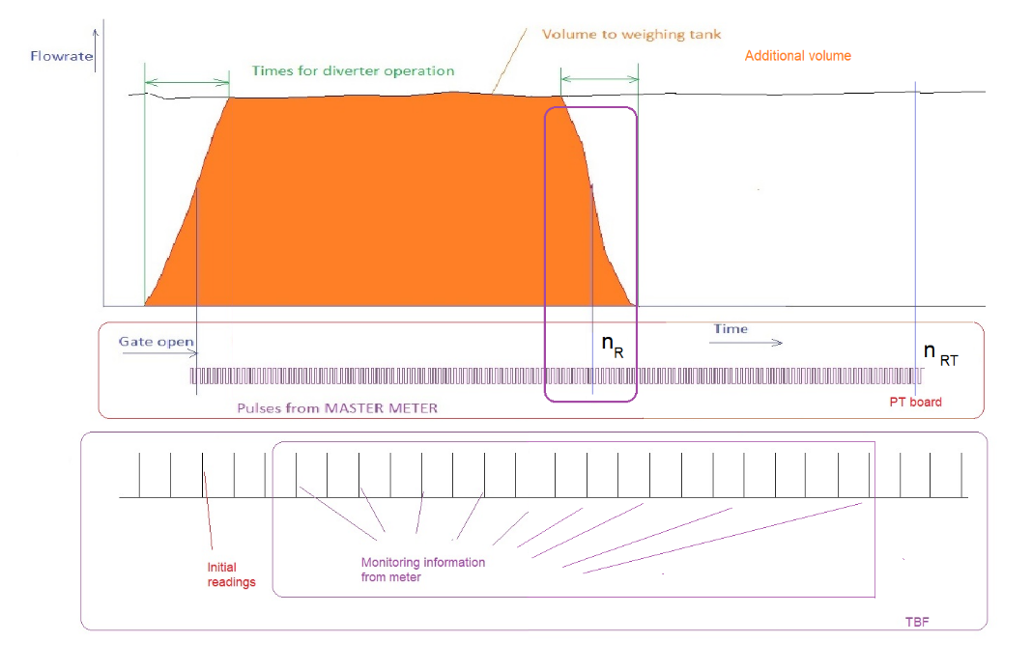

State 5
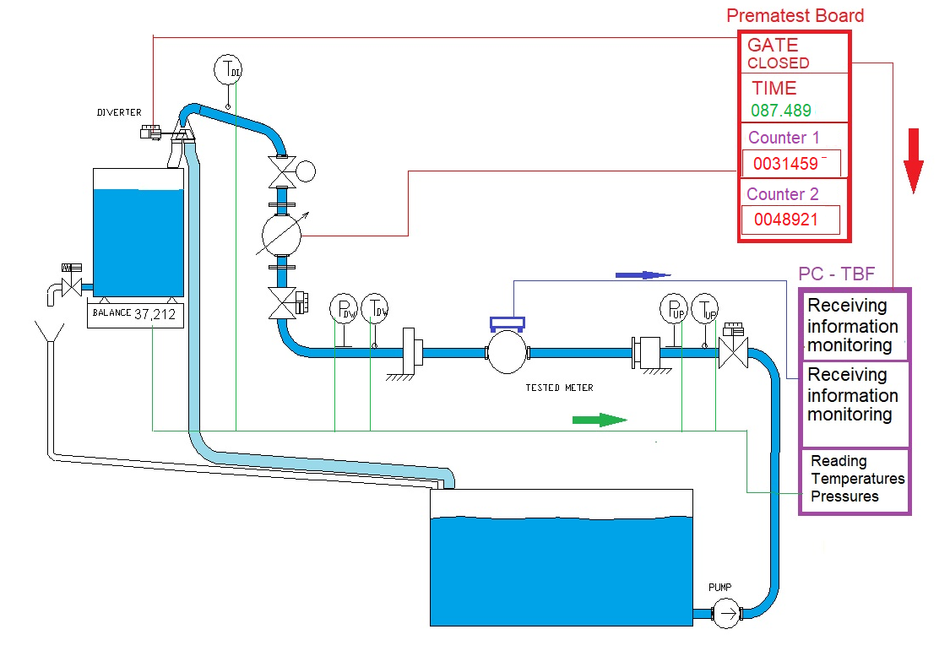
TBF is continuing the test with master meter. Second counter of master meter is still running and also time counter for τ_{RT} .

STATE 6
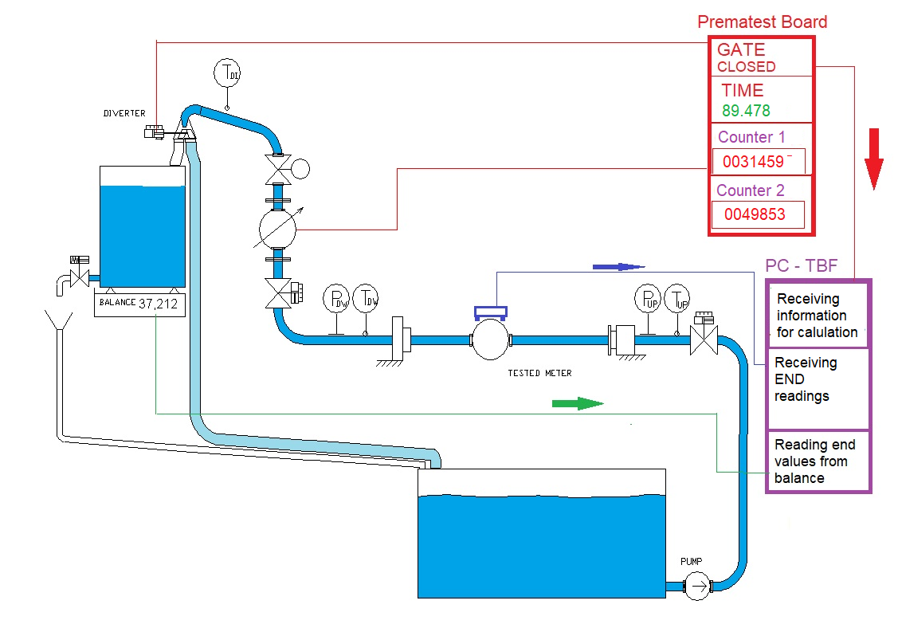
End of the test. Closing gates fro second counters of master meter pulses and for time.
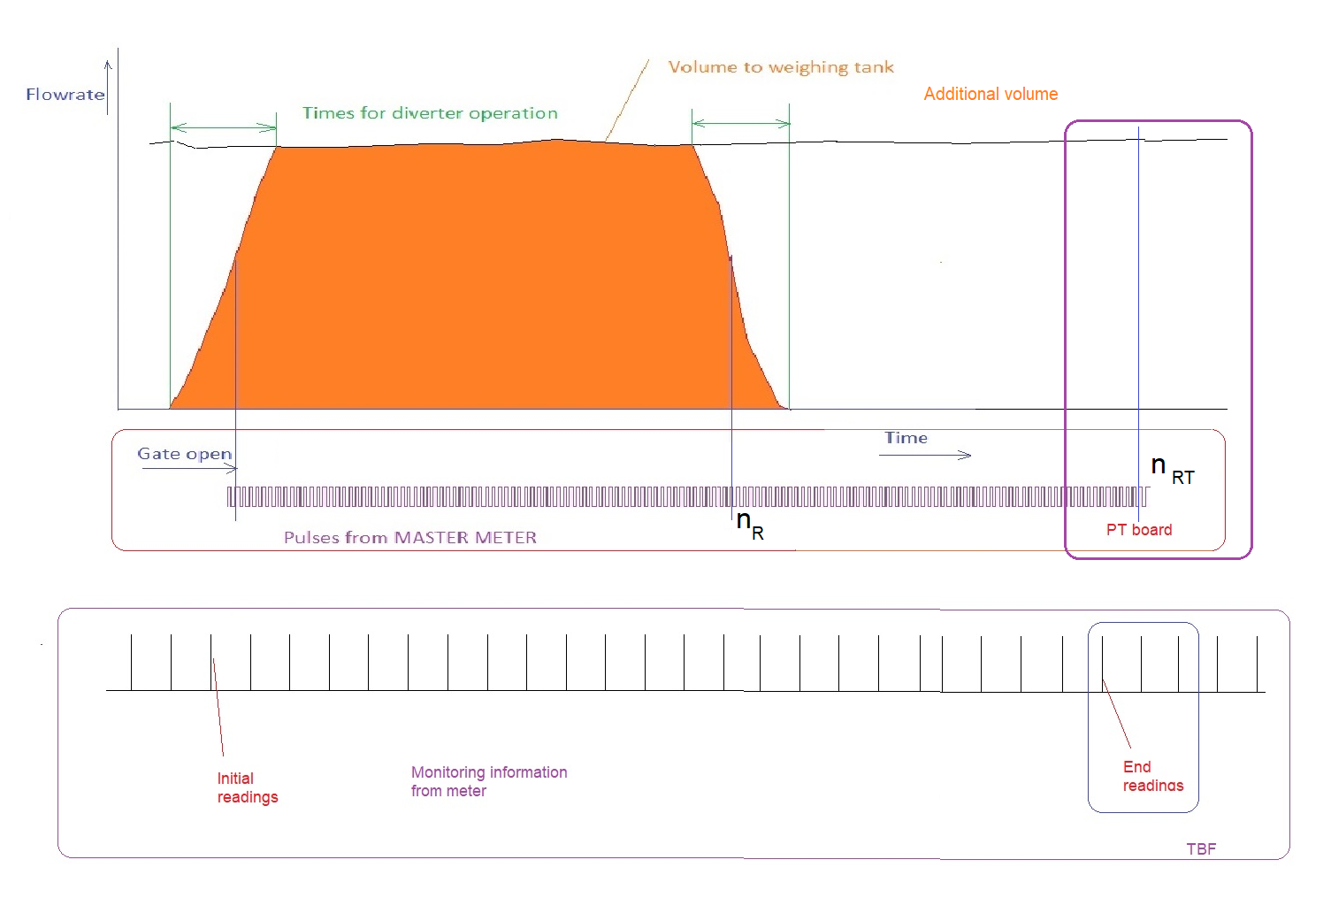
TBD is collecting all required data from PTB and reading values form balances. The conventional true value for each tested meter is different due to different time of incoming readings. System is calculating conventional true value of the system, volume from each tested meter and correct volumes from each meter.
TBF is receiving following information
From PTB - n_{RT}[-] and τ_{RT}[s] ,
From tested meters, V_{mdEN} [dm³], and τ_{mdEN}[s]
From Balance , M_{RENB} [kg]

For each meter the TBF is calculating volume using formulas (V7), (V8) (V9)

Where [s]

Flying start and stop collection method with process camera.

This method requires mechanical water meter with mechanical register. Register can be with pointer or roller. Camera can work with more elements as more pointers or rollers.
This method is similar to the method with pulses.
This method requires definition of the register profile.
Register profile means:
- Number of reading elements (up to 4) (stars, pointers, roller)
- Sizes
- Direction of rotation
- Number of teeth
- Optical properties as background correction
The conventional true volume and the related reference time for this method are receiving from Premetest board (PTB). The PTB is sending related information to TBF one times per s. Process camera is sending information directly to TBF.
Before starting the measurement, each camera must provide detection process to find the related element for further reading.

State 0 - Detection
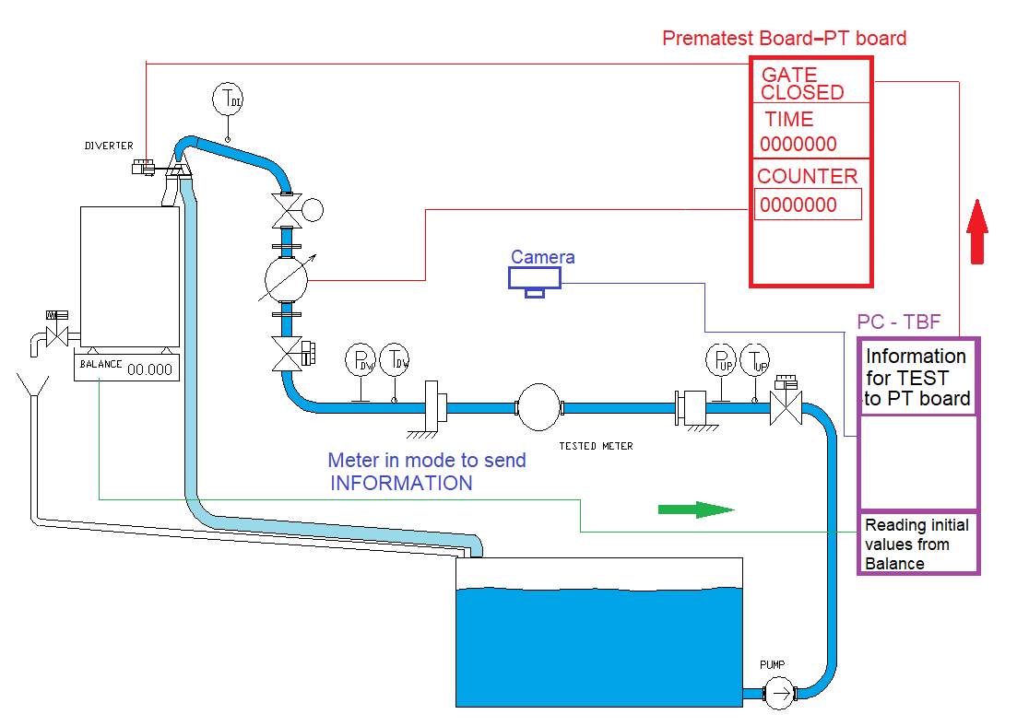
TBF is sending information to PTB and to Camera for detection.
After reaching defined flowrate TBF is requiring from camera to provide detection process.
After successful detection, camera is ready to start the measurement.

State 1
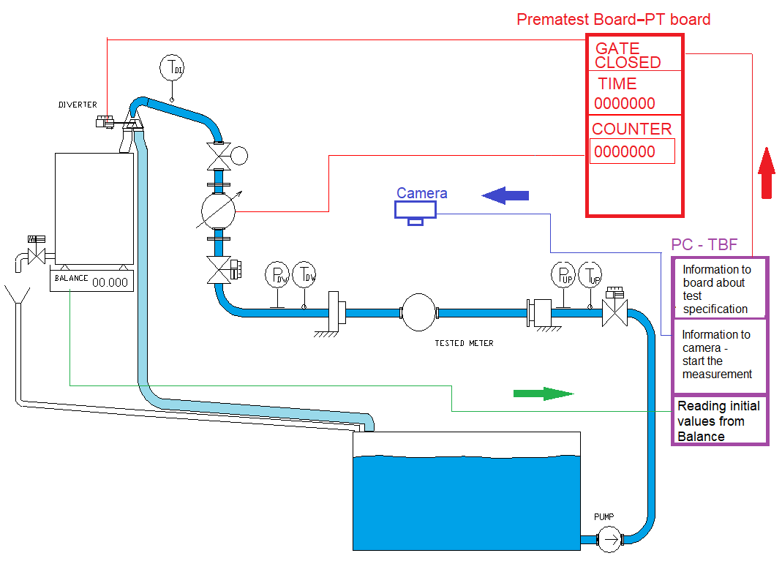
State 1: Water is flowing through the testing line to the reservoir.
System is adjusting the correct flowrate.
System is reading the actual weight. In the case of not enough mass, TBF is emptying the weighing tank.
TBF is reading the weighing machine information according to defined reading process and calculate the.
TBF is waiting until defined time.

State 2
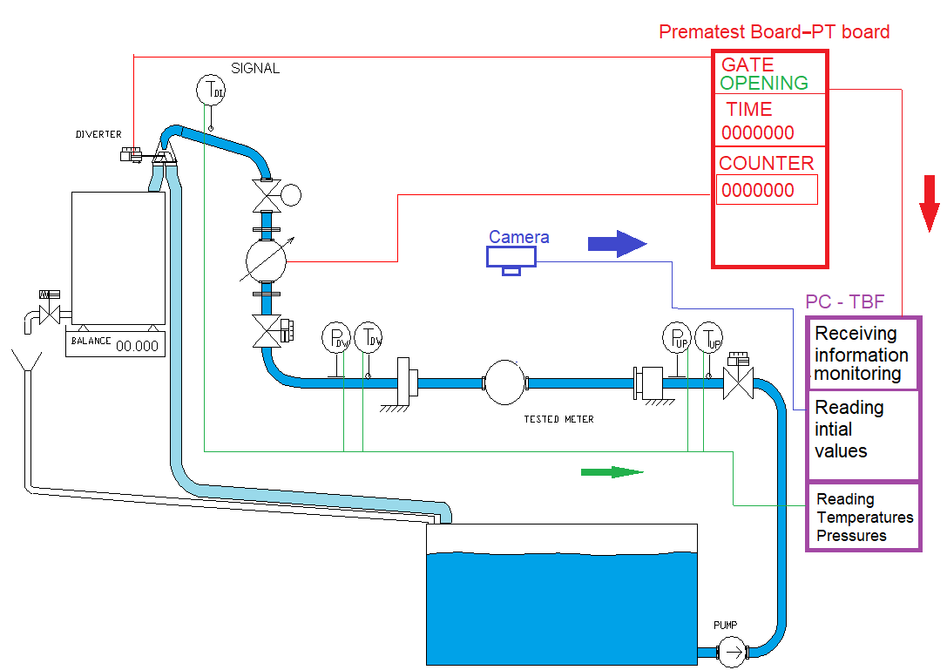
Diverter is switching to the position “Weighing tank”. Gate for pulse counter of the master meter is opening, also gate for testing time is opening. TBF is reading initial value - Angle from camera φ_{ST} and start time form the camera. Values are actual angle and time τ_{mcST} . TBF is starting to collect actual state values described in the chapter “Actual state values”

State 3
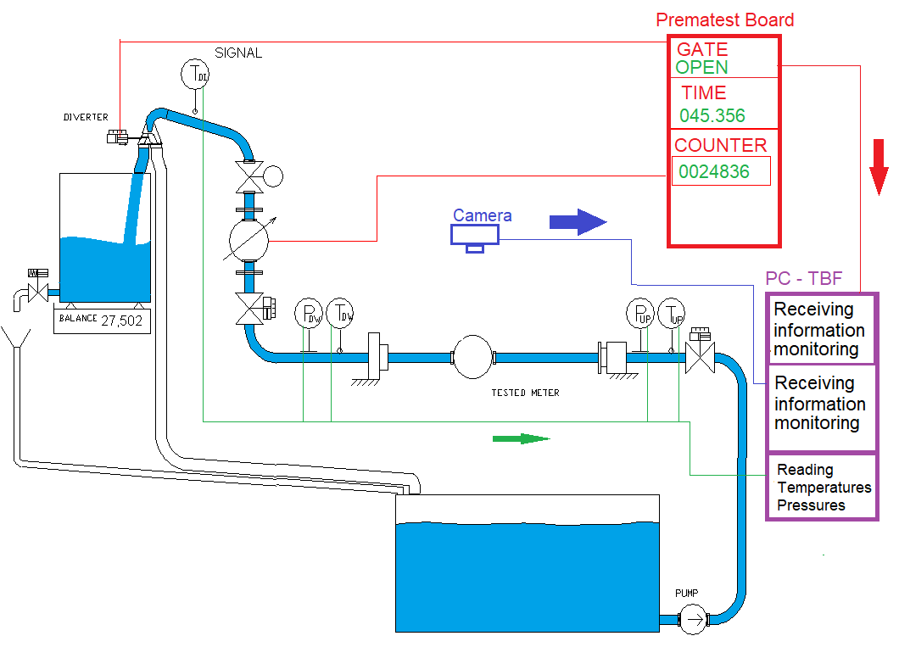
Water is flowing to the weighing tank. TBF is monitoring the process and reading actual state values and also readings from cameras.
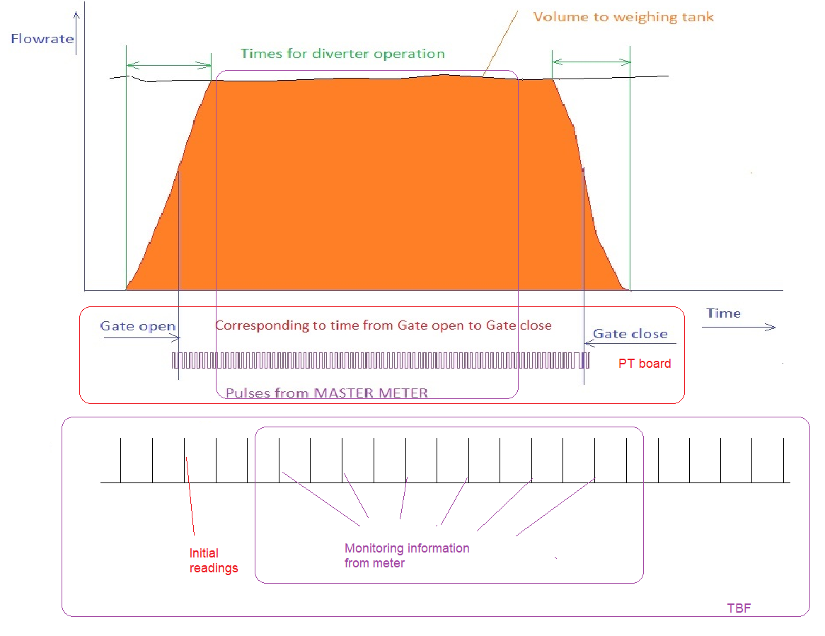

State 4
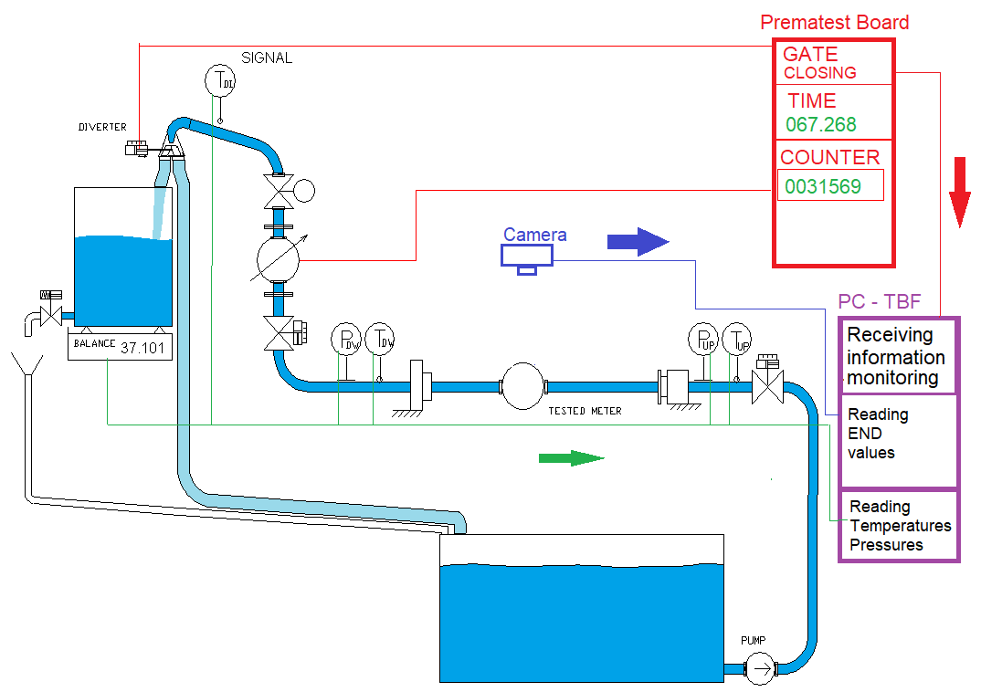
End of test for conventional true value. Diverter is changing its position to “reservoir”. Signal from diverter is closing the gate for pulses and time. TBF is reading end values from cameras.
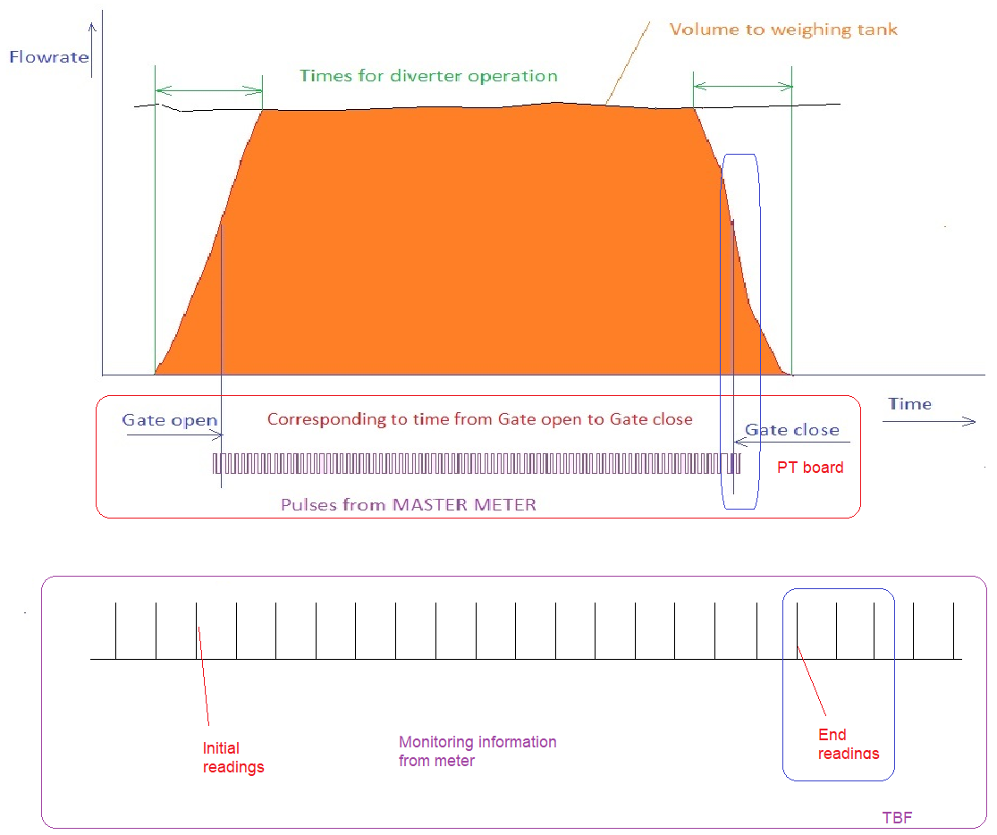

State 5
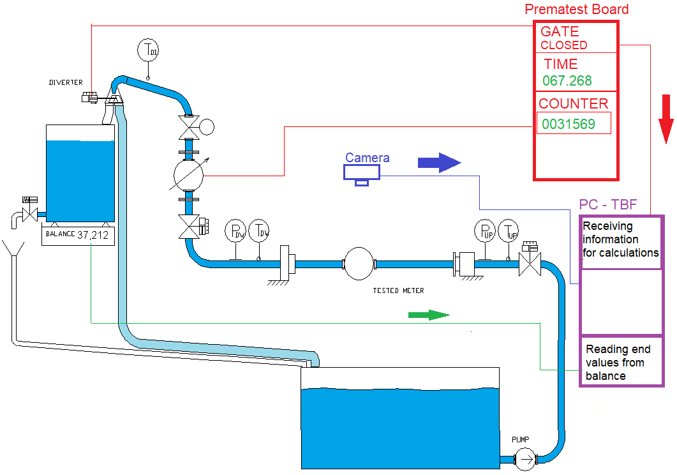
TBD is collecting all required data from PTB and reading values form balances. The conventional true value for each tested meter is different due to different time of incoming readings. System is calculating conventional true value of the system, volume from each tested meter and correct volumes from each meter.
TBF is receiving following information
From PTB - n_{r}[-] and τ_{rt}[s] ,
From Cameras, φ_{EN} [deg], and τ_{mcEN} [s]
From Balance , M_{RENB} [kg]

For each meter the TBF is calculating volume using formulas (V10), (V11) (V12)

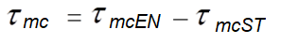 [s] (C1)
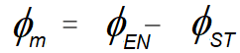 [deg] (C2)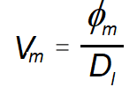 [dm³] (C3)

Flying start and stop with master meter using synchronization

a from master meter pulses.

b from time pulses

This method requires pulse output from tested meter. Tested meter can generate pulses directly or for mechanical registers optical sensors can generate pulses. Requirements from pulse properties are the same as for collection method with weighing machines.
Prematest board controls this process in teal time.
PTB and TBF is working with both methods. The basic principle is the same only the additional counter is counting pulses from master meter or from time.

State 1
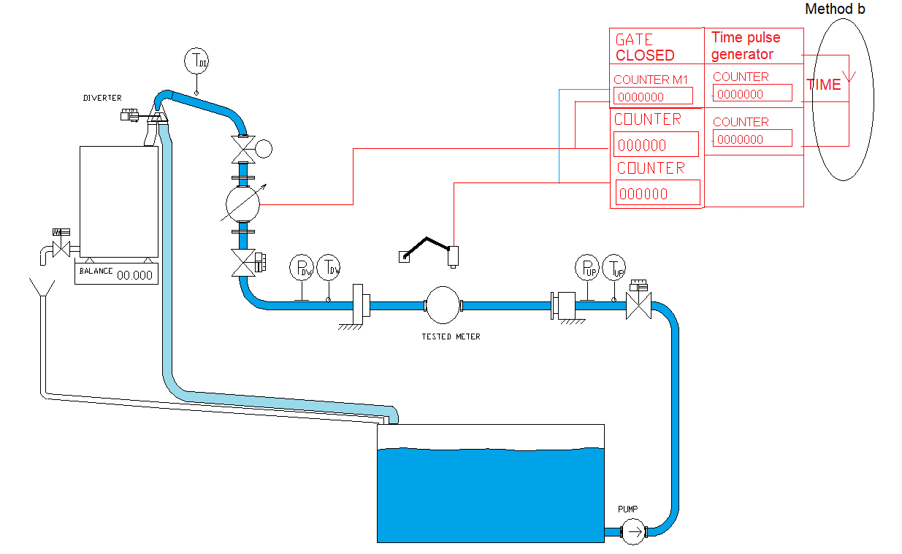
State 1: Water is flowing through the testing line to the reservoir.
PTB is adjusting the correct flowrate.

After stable flow, TBF can wait until defined time.
Diverters and weighing machines are not in use for this method of operation

For correct measurement, master meters must be calibrated before providing tests using this method of operation.

State 2
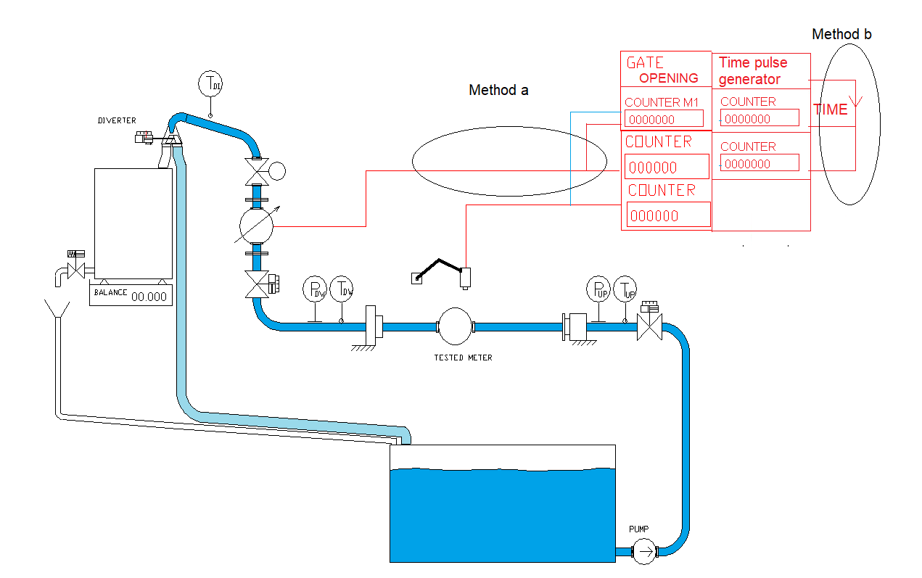

PTB is starting the measuring process by opening gates for counters from master meter and time measurement.
System is waiting for the first pulse from tested meter. In this state it is exactly the same as for collection method flying start and stop. TBF is storing actual state values.

State 3a
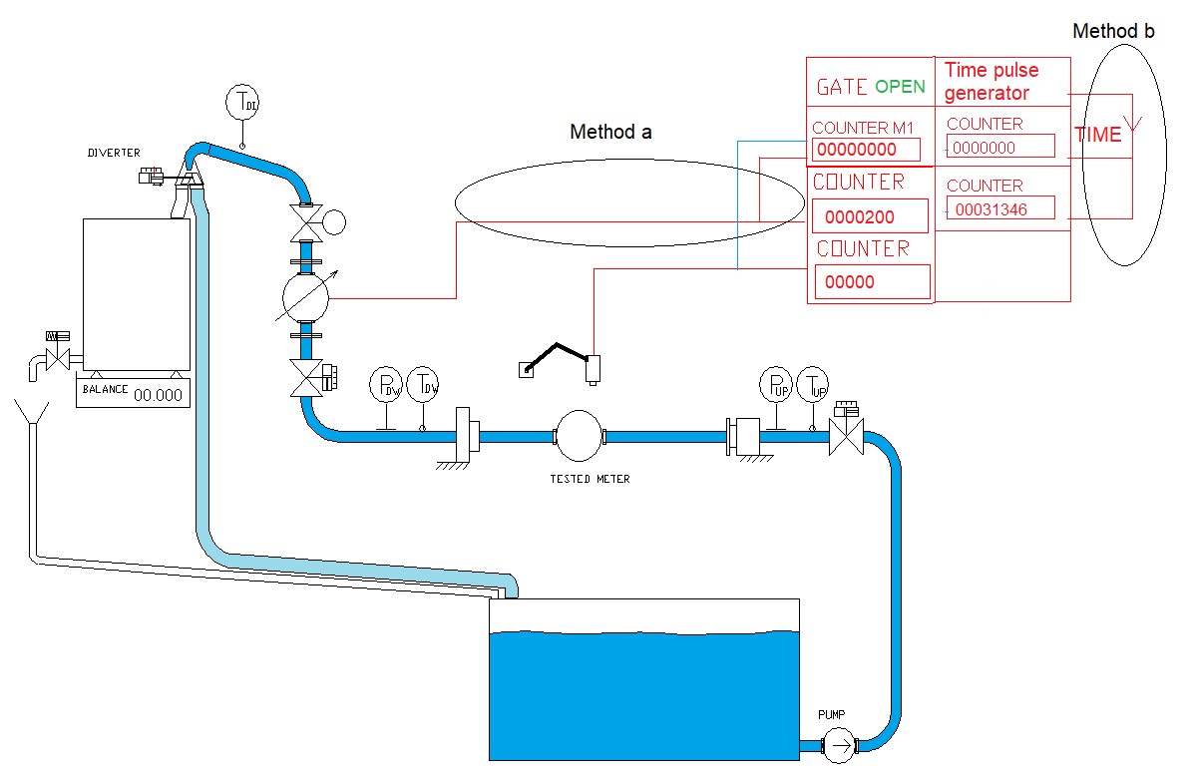

Water is flowing to the weighing tank. First pulse from tested meter is opening the gate for the additional counter for master meter for method a and additional counter for the time for method b.
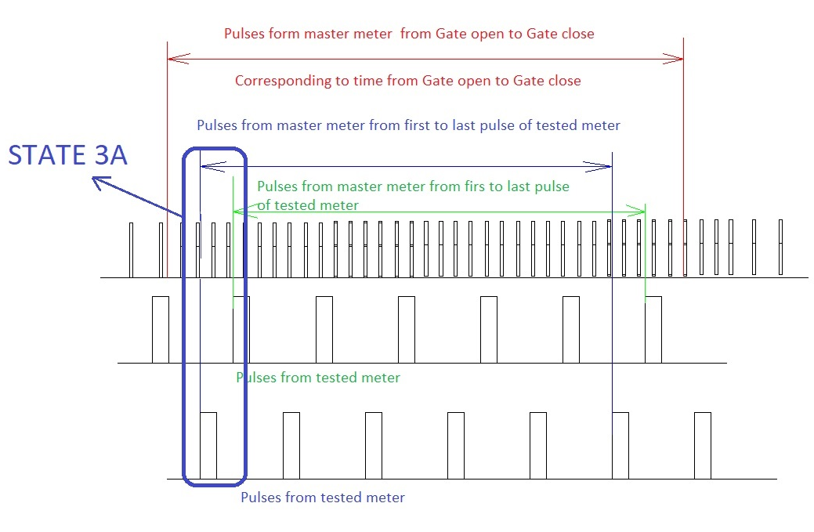

State 3b
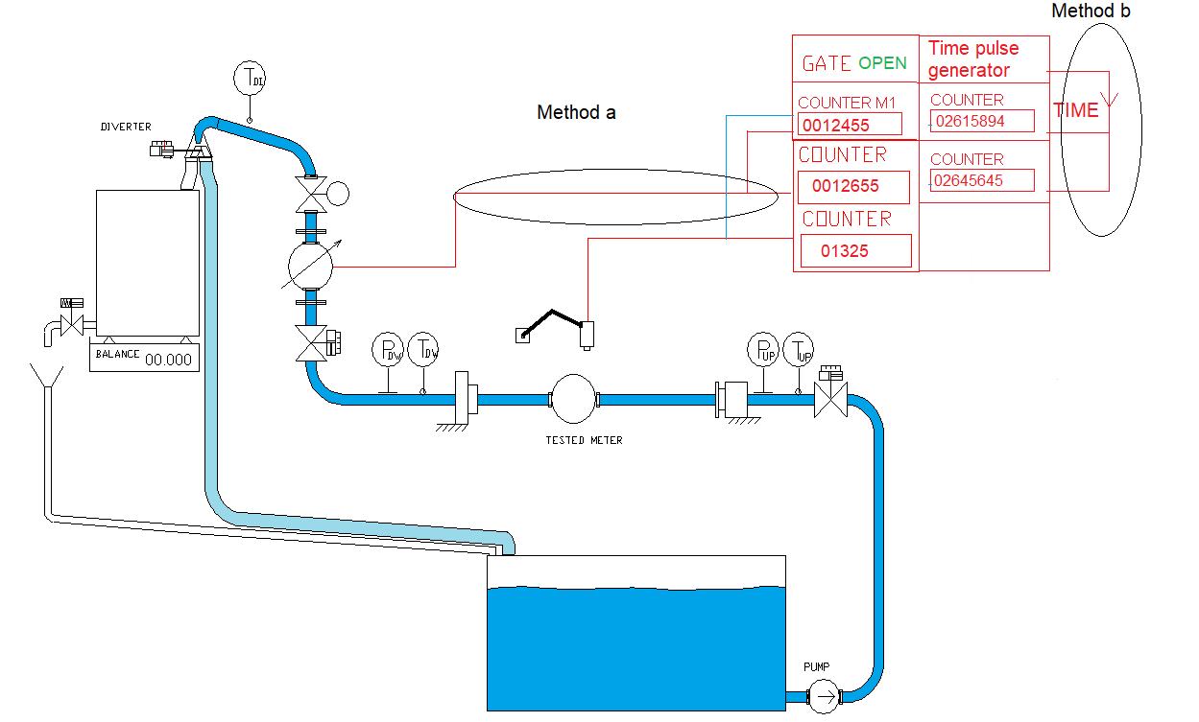

System is counting pulses from Master meter, tested meter and additional master meter pulses from the first coming pulse for method a or time for method b. TBF is reading actual state values.

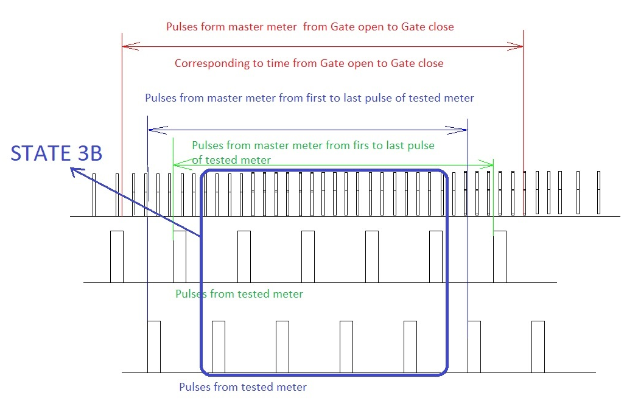

State 3c
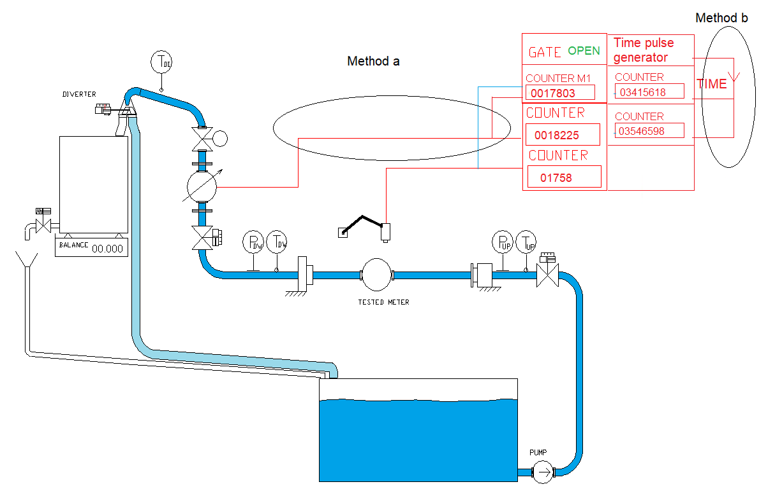

The last pulse from the tested meter (before diverter is switching back) is the gate for the additional pulse counter from the master meter for method or time pulse for method b.
Every tested meter is having additional counter of the master meter / time pulse.

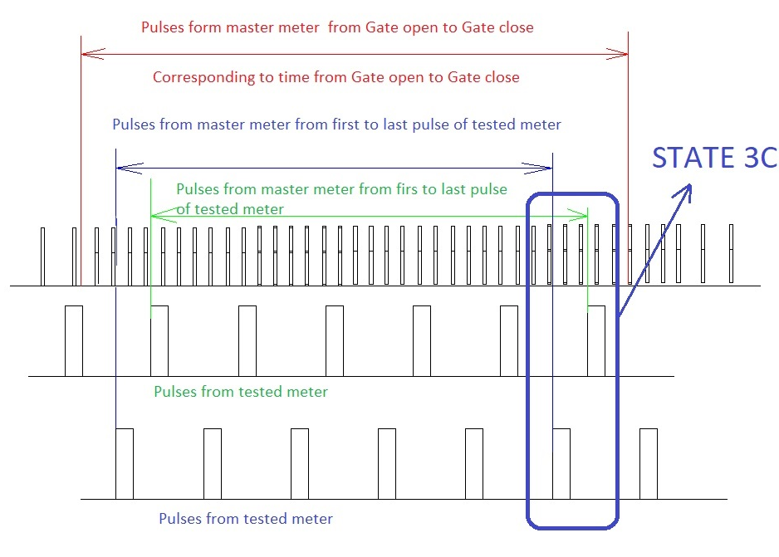

State 4
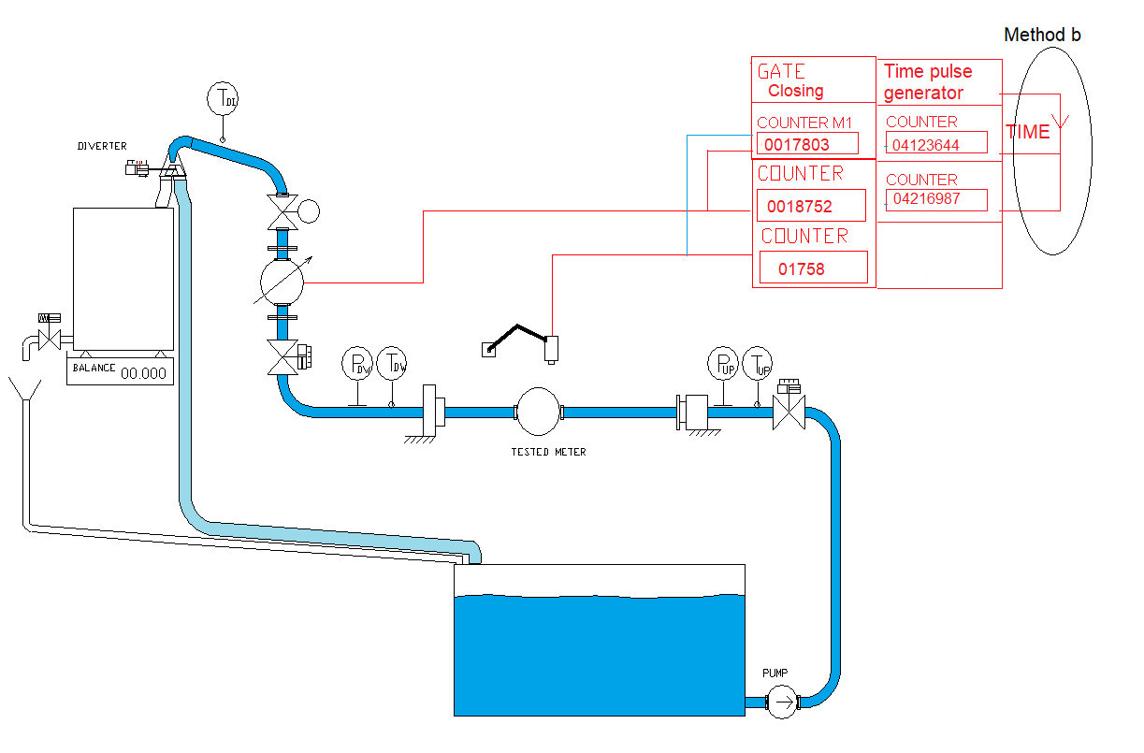
End of the test. Gate is closing from PTB signal.

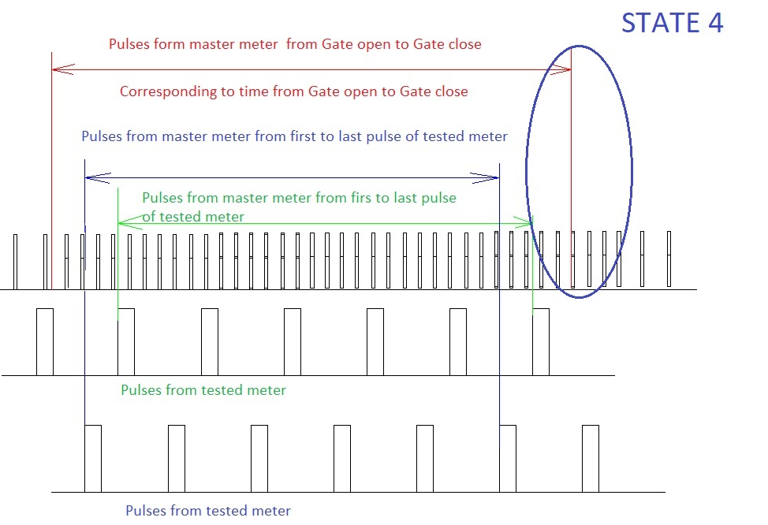

State 5

TBF is collecting all data from PTB and from the balances. The correct value for each tested meter is different due to different number of pulsed obtained from master meter corresponding to tested meter. System is calculating the master meter error.
TBF is receiving following information
From PTB - n_{r}[-] and τ_{rt}[s] for reference meter, n_{m}[-],n_{rm}[-] and τ_{m}[s] for each tested meter

For each meter the TBF is calculating meter volume according to formulas formulas (V16), (V17) and (V18). Correct volumes are calculating according to formulas (V1), (V2), (V3) and (V4), (V5), (V6).

Each meter is having different correct volume, which is given from the conventional true value from the weighing method multiplied by C_{MMP} correction.

The conventional true volume we receive from following formula

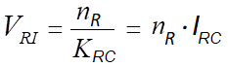[dm³]
Where

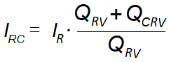[dm³]

Standing Start and Stop (Manual reading)

Standing start and stop method using manual reading and mass measurement for determination of conventional true value.
This method does not require electronic outputs from tested meters. Values - readings are manually typed to the PC.
Time and actions are controlled form TBF not from PTB.

State 1
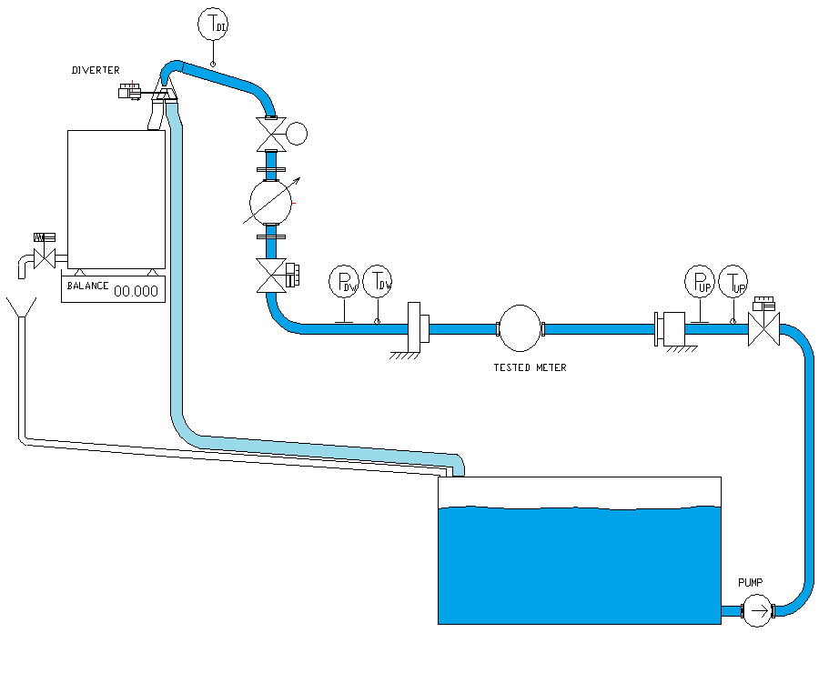
State 1: Flowrate is running through the selected paths and preparing meters for test.

State 2
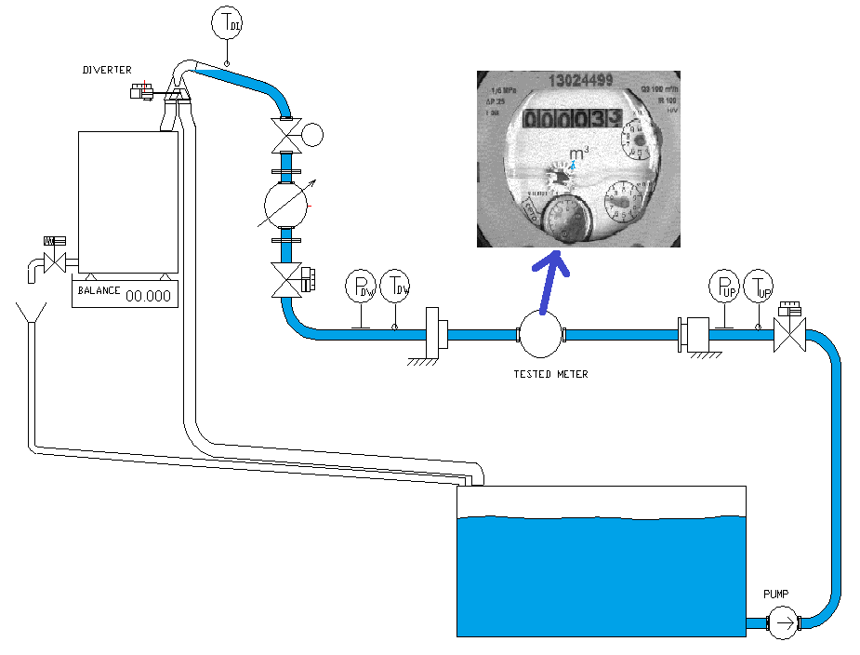

State 2: Flowrate was stopped by Start-Stop valve, Operator read the meter and type it to the PC.
Operator read the value 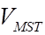 for each meter.
After reading all meters, the diverter position will be changed to “weighing tank”.
After changing the diverter position, the START-STOP will open and the water will flow to the weighing tank.
Opening time of the valve will be stored.

State 3
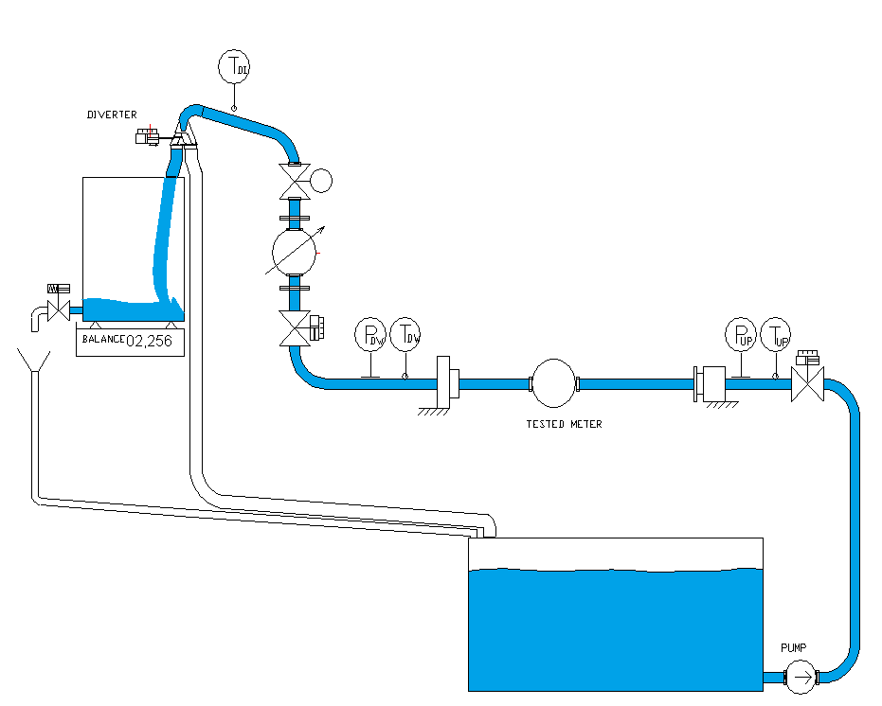

State 3: Collection of the water in the weighingt tank is running. Actual state from the system is displyed.

Actual integrated flowrate, volume from master meter are displayed.
Time and actual temperature is visible. TBF is storing state values as described in the chapter “State values”
The staring process for flow is from 30% of the measuring time but minimum after 5 s

State 4
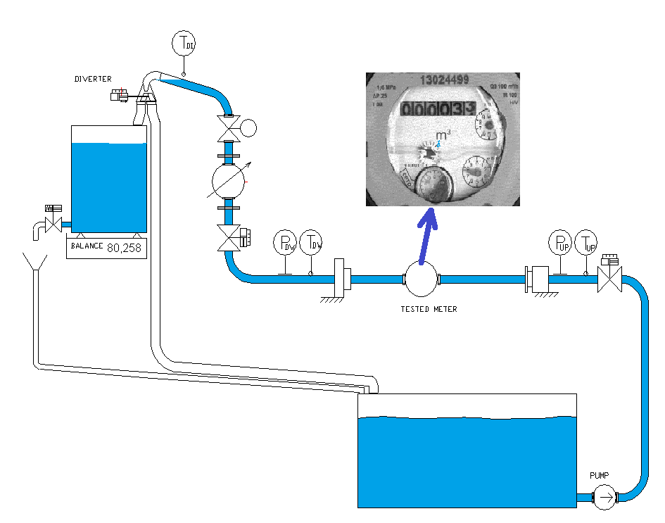

State 4: START – STOP valve stops the collection process. Closing time of the valve will be displayed and stored. System is asking operator to type values from tested meters.
After typing the end readings, system read the end weight from weighing machine and calculate all required data for the test.
Operator is reading values 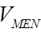 from water meters . [dm³]
TBF is calculating 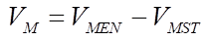 for each meter. [dm³]

