Project Number:  14011 | Document Type:  Quick Reference |  |  | 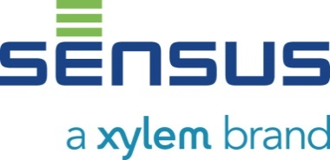
Date:  30-May-2024 | Product Name:  GenesisToolBox |  |  | Revision:  B
History:
Rev | Date | Comment | Author
A | 14-Apr-2023 | Initial derived from TBF_FW_UPDATE | Thomas Wiedebusch
B | 30-May-2024 | Credential input GTB 2.6.7 | Thomas Wiedebusch

Copyright © 2023..2024 by
SENSUS GmbH
CONFIDENTIAL
File: Quick Reference GenesisToolBox Main and Setup.docx

Reviews
Rev | Date | Reviewer | Department

List of Contents
1 General Part 6
1.1 Introduction 6
1.2 Document Content 6
1.3 System Overview 6
2 Prerequisites 10
2.1 Hardware Requirements 10
2.2 Software Requirements 10
2.3 Network Connection 10
2.4 Mini-MOXA Installation 10
2.5 Mini-MOXA Setup 11
2.6 Micro-MOXA Driver Installation and Setup 11
3 GTB 12
3.1 Installation 12
3.2 License 12
3.3 Start 13
3.3.1 Slot 16
3.3.2 General 19
3.3.3 OfflinePasswords 20
3.3.4 Logging 21
4 Troubleshooting 22
4.1 Licence Expired 22
4.2 Connection Problems 22
4.3 Invalid Slot Selection 22
4.4 Password Access 23
4.5 Light Sensistivity 23
5 Contacts 23
List of Tables
Table 1.1 Abbreviations 5
Table 5.1 Contacts 23

List of Figures
Figure 1.1 System Overview with Cordonel Interface Mini-MOXA 7
Figure 1.2 System Overview with Cordonel Interface Micro-MOXA 8
Figure 1.3 System Overview with Cordonel Interface USB-IrDA 9
Figure 2.1 Mini-MOXA Serial Ports setup 11
Figure 3.1 License Request Error Message 12
Figure 3.2 Missing Setup Message 13
Figure 3.3 GTB Main Launcher – Not logged in 13
Figure 3.3 GTB Main Launcher – Not Logged In 14
Figure 3.3 GTB Main Launcher – Credential Manger 14
Figure 3.3 GTB Main Launcher – Logged In 15
Figure 3.4 GTB Empty Setup Slot Window 16
Figure 3.5 GTB Valid Setup Slot Window 17
Figure 3.6 Request Port Validated 17
Figure 3.7 Request Port Detection Failed 17
Figure 3.8 SerialConfig.json – Example Configuration 18
Figure 3.9 GTB Setup General Window 19
Figure 3.10 GTB Setup Logging Window 21
Figure 4.1 Licence Expired Message 22
Figure 4.2 Invalid Slot Selection Window 23

Abbreviations
Common | Implementation of commonly used functions
Cordonel™ | Water meter with ultra-sonic measurement, initial name GENESIS
DB | Data Base
GENESIS | Legacy name for the Cordonel™
GTB | GENESIS Toolbox, selection of Tools to access to the Cordonel™ internals
HW | Hardware
ID | Identification number
IrDA | Infrared Data Association, used as serial communication interface
LED | Light Emitting Diode, used as serial communication interface
PCB | Printed Circuit Board, the Cordonel™ electronics
SW | Software
tbd | to be defined
TBF | Test Bench Framework, the entire SW for the test benches and meters
UM | User Manual
VPN | Virtual Private Network
Table 1.1 Abbreviations

General Part

Introduction
The Cordonel™-Water-Meter is an ultrasonic measurement equipment. It needs an electronics to generate the sound waves and to measure the Time-Of-Travel through the fluid. Supporting the flexibility of different meter sizes in addition with functional setups, the hardware is controlled by a firmware. During the development and the production process several actions have to be executed to influence the operation and state of the Cordonel. Therefore a software has been designed as part of the Test-Bench-Framework which is included in the GENESIS Toolbox.
After the completion of the assemble procedure of the Cordonel™, the remaining bi-directional communication interfaces are the Radio-Interface, European Market, and the IrDA serial interface.

Document Content
This document covers the required HW, FW and SW for the GTB. Setups needed to be done, as well as files, used as interfaces, and the structure of the SW will be summarized.

System Overview
Three hardware systems can be used for the firmware update:
- USB-IrDA: The IrDA Plug-In adaptor is directly connected via USB to the PC. No driver installation is required.
- Mini-MOXA: The IrDA Plug-In adaptor is connected via a box containing an interface with a high noise immunity for harsh environments. A driver needs to be installed to support the RS485-4W interface. The Mini-MOXA needs an external power plug to supply the IrDA. It has two channels to support the LED (Streaming port) and the IrDA (Request port).
- Micro-MOXA: The IrDA Plug-In adaptor is connected via a box containing an interface with a high noise immunity for harsh environments. A driver needs to be installed to support the RS485-4W interface. The Micro-MOXA used the USB to generate the power supply for the IrDA had. This devices has only one channel for the IrDA (Request port).

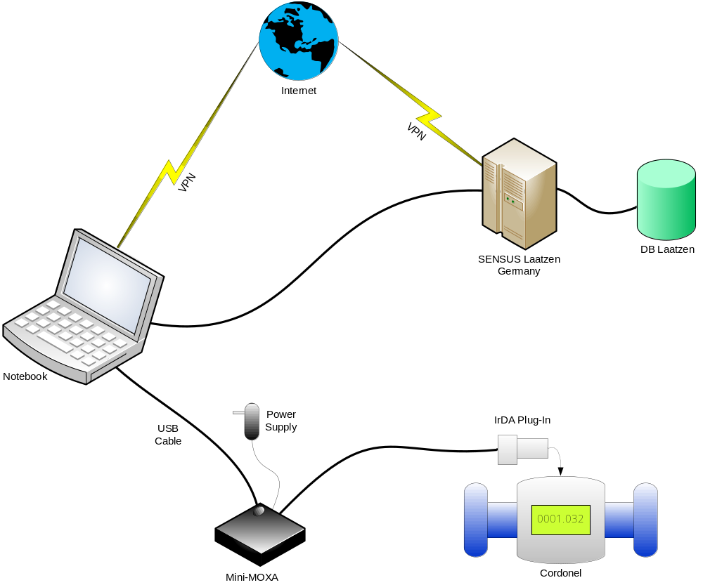

Figure 1.1 System Overview with Cordonel Interface Mini-MOXA
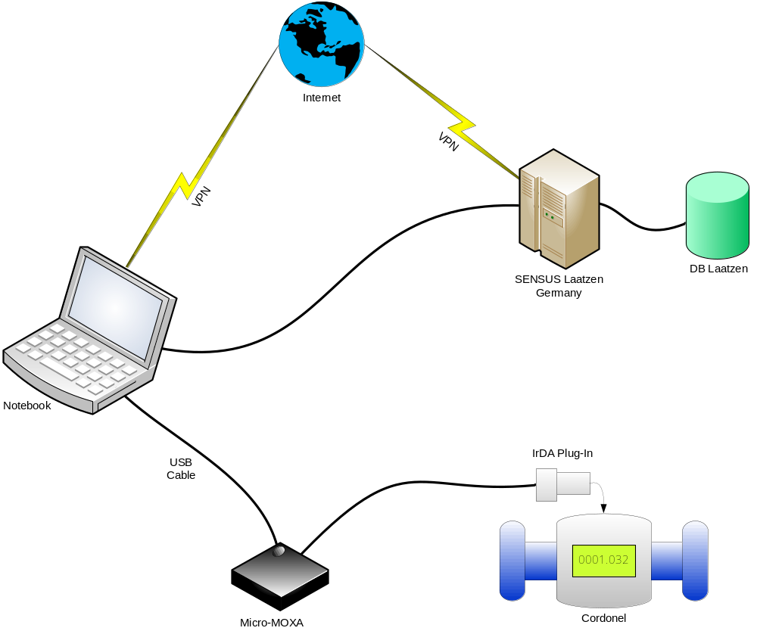
Figure 1.2 System Overview with Cordonel Interface Micro-MOXA
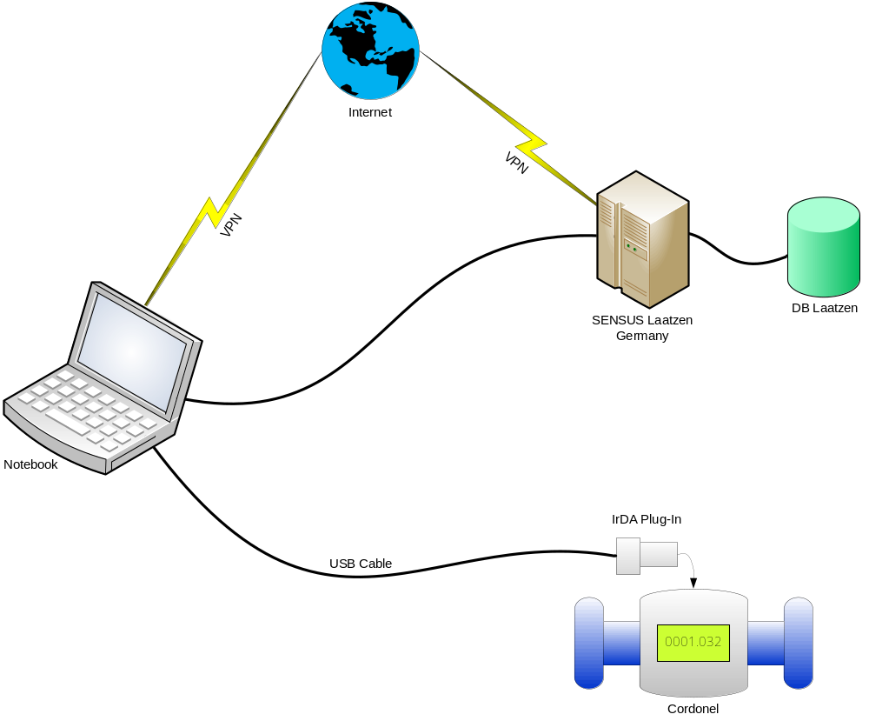
Figure 1.3 System Overview with Cordonel Interface USB-IrDA

Prerequisites
This chapter listes the SW and HW needed for the GTB and the connections to the Cordonel.

Hardware Requirements
- PC with MS-Windows™ 10 Operating system.
- USB-IrDA, Mini-MOXA or Micro-MOXA with IrDA head.

Software Requirements
Microsoft™ .NET framework 4.7.2 has to be installed in advance.

Network Connection
A VPN connection or a direct network access has to be established to access the SENSUS Laatzen network. This connection is needed to get a valid licence for this software, to access the Cordonel password, to download the latest used interface-description-file (configuration.json).
In case of problems setting up the network connection regarding the VPN, contact the SENSUS IT department.

Mini-MOXA Installation
To support the Mini-MOXA a driver has to be loaded from the Share-Point:
http://project.emea.sensus.net/PWA/EMEAAP_Genesis/Project Documents/300_R+D/340_Software+Firmware/342_Software_and_Firmware/343_Driver/driv_win_uport_v3.0_build_18080316_whql.exe
Download and install this before connecting the Mini-MOXA.

Mini-MOXA Setup
After the Mini-MOXA installation, the serial ports have to be setup to “RS-485 4W” as this is the IrDA-Plug-In HW-interface. Therefore start the “Device Manager” with administrator rights, select “Multi-port serial adapters->MOXA Uport 1250 Series” and adjust both serial ports as shown:
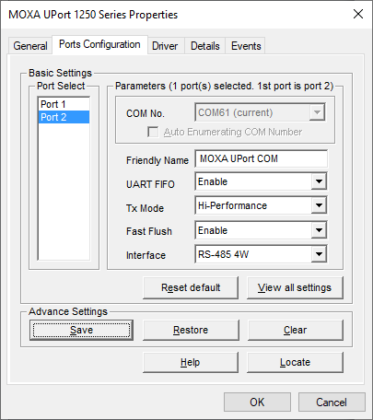
Figure 2.1 Mini-MOXA Serial Ports Setup
The Mini-MOXA status LEDs underneath the small round window in the Mini-MOXA box will show the setup of the interface (red LEDs) and blink on an active communication (yellow LEDs). Check the 4W RS-485 LEDs being active.

Micro-MOXA Driver Installation and Setup
For the Micro-MOXA internally using the UPort 1130 Series with on serial port (here shown a type 1250 with two serial ports), a driver has to be installed and setup with administrator rights.
Link to the Micro-MOXA driver (08-Mar-2023):
https://www.moxa.com/en/support/search?psid=114473
After installation this device is visible on Multi-port serial adapters and mapped to one Port (COM & LPT) named MOXA UPort Com Port 1 (COMxx) assigned to a serial COMxx interface. Setup the single port identically to the Mini-MOXA to “RS-485 4W”

GTB

Installation
Download the latest GENESIS Toolbox (GTB) which can be found at:
http://project.emea.sensus.net/PWA/EMEAAP_Genesis/Project Documents/300_R+D/340_Software+Firmware/342_Software_and_Firmware/GenesisToolBox
For licence information contact the SW Developer.

An installation is not required, simply store the GTB to a preferred folder e.g.:
C:\users\[userName}\Downloads\GTB\V2.4.0\*.*
It is possible to download multiple toolboxes, as the functions may be limited to some versions.

License
To start the SW double click the Xylem.Common.Ui.GenesisToolBox.exe in the GTB main folder. Be aware to start the VPN connection in advance.
The GTB license will be controlled via the production data base. If not connected to the Xylem network or on an outdated GTB this message will be shown:
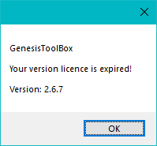
Figure 3.1 License Request Error Message

Start
At the very first start of the GTB on this machine, the serial ports for the IrDA-Plug-In have to be setup indicated by:
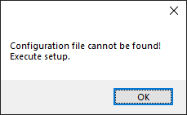
Figure 3.2 Missing Setup Message
The start window is going to be displayed at every program start. If the [Missing Setup Message] appears , the “Setup” has to be selected. Clicking [OK] will open the the main launcher for all underlaying programs.
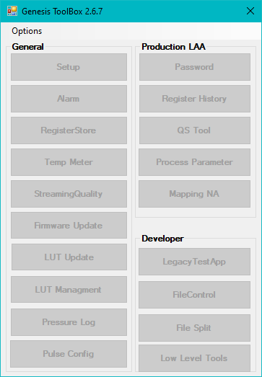
Figure 3.3 GTB Main Launcher – Not Logged In
If not logged in to the GTB clicking “Options” is going to open the “Login” selection:
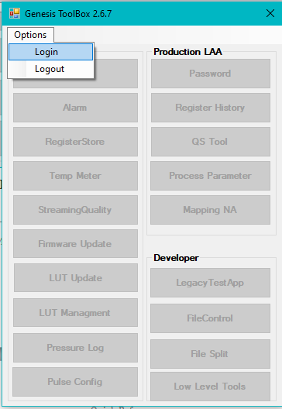
Figure 3.4 GTB Main Launcher – Not Logged In
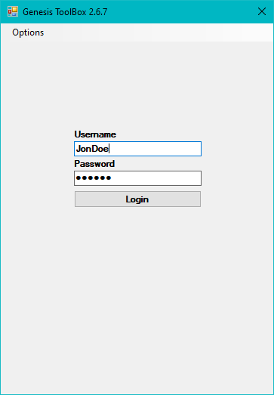
Figure 3.5 GTB Main Launcher – Credential Manager
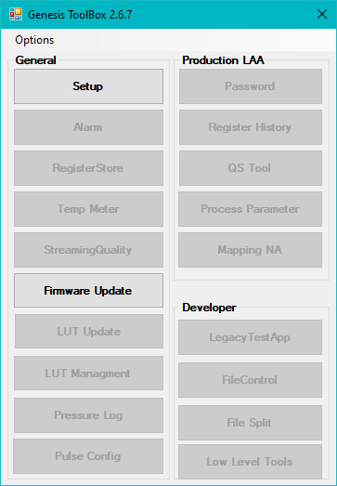
Figure 3.6 GTB Main Launcher – Logged In
After the login the buttons assigned for a specific user are active. The access rights are controlled by the access administrator in the Laatzen DB.
Setup
The [Setup] program configures the interfaces and fucntions of the GTB.

Slot
A [Slot] is the placeholder for the interfaces to one Cordonel™ which uses as standard water-meter two serial-ports. The two ports using different protocols and HW interfaces, a request-protocol, for bi-directional communication over the IrDA interface, and a streaming-protocol, for the uni-directional measurement data via the LED.
On the first start of the GTB on the current machine an empty setup will be displayed.
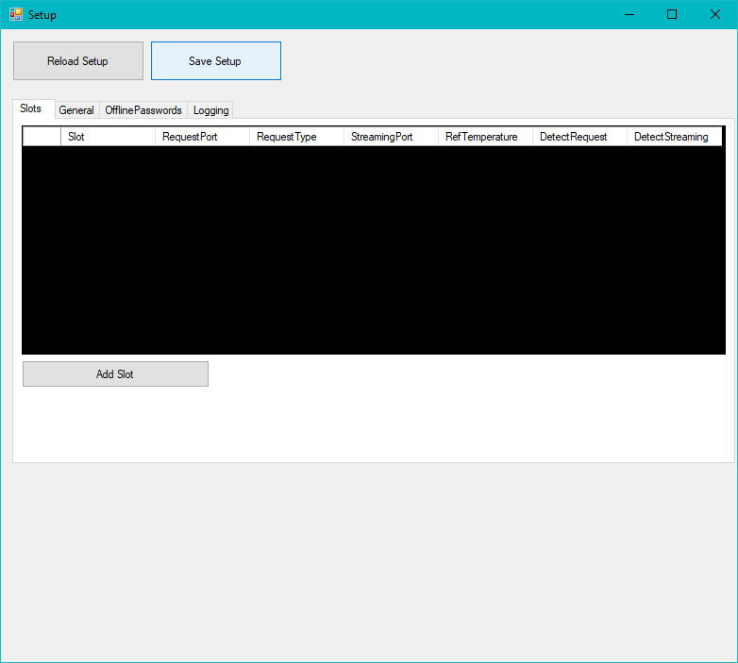
Figure 3.7 GTB Empty Setup Slot Window
Pressing [Add Slot] button, insertion of a “1” to the first “Slot” row, selecting the “RequestPort” number, “RequestType” to “IrdaSerialPort” and “StreamingPort” number have to be done as shown, the port numbers must be identical to the settings done in [2.5]. The “RefTemperature” has to remain unselected. This is for special devices used for reference temperature measurements during flow-tests.
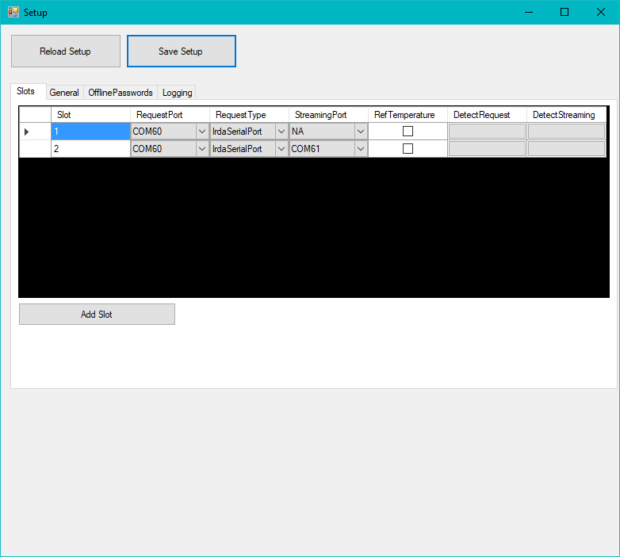
Figure 3.8 GTB Valid Setup Slot Window
Pressing “Save Setup” will store the configuration.
With the “DetectRequest” the port can be checked, the “DetectStreaming” will not operate here without additional settings (it is inactive and has to activated by other tools of the GTB), so this doesn’t matter.
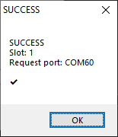  Figure 3.9 Request Port Validated | 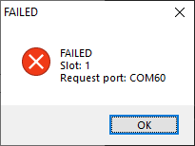  Figure 3.10 Request Port Detection Failed
It is possible to setup several slots to support multiple GTB instances to update multiple Cordonels™ by the same PC simultaneously.
After the setup the file controlling these settings are located in:
C:\users\[userName}\AppData\Roaming\Genesis where userName is the login name.
The SerialConfig.json file links the serial port-numbers to the slot and the protocol for each individual port.
Example:
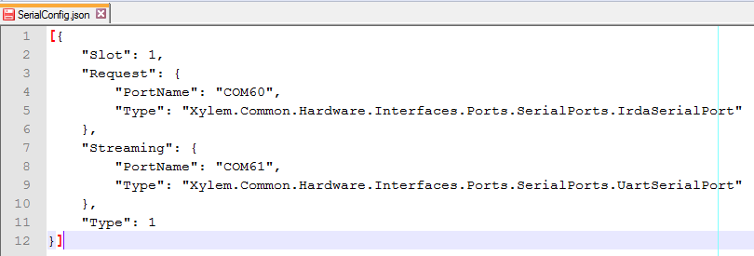
Figure 3.11 SerialConfig.json – Example Configuration
Do NOT edit this file manually, leave this to the [Setup] tool of the GTB.

General
The [General] tab will setup the GTB DB interfaces and opertion like logging.

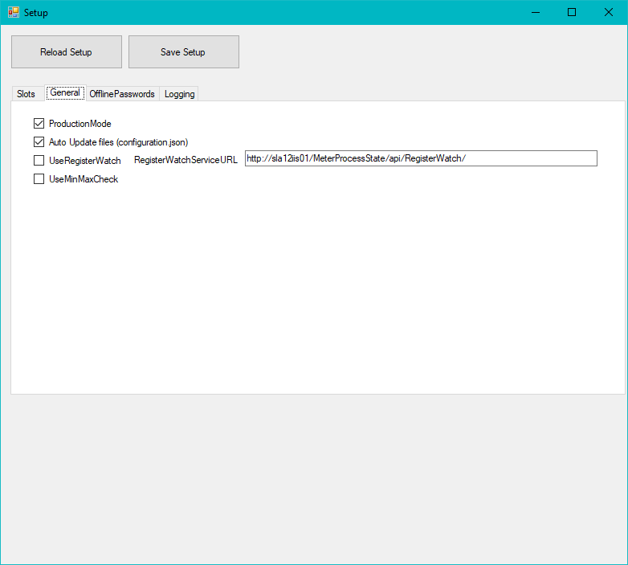
Figure 3.12 GTB Setup General Window
ProductionMode:
Access to released configuration.json is required to avoid malfunction of production depending setups. For development uncheck this checkbox.
In non production mode (developer mode) a register check may fail or not all registers may be accessable.

Auto Update files (configuration.json):
Checking this will automatically download the latest “released” configuration.json from the Laatzen DB. If the network connection is not established, the curren file will be kept. For development purposes unchek this checkbox to avoid overwriting of the manual modified configuration.json .
The configuration.json will be stored in the main folder of the GTB executable.
UseRegisterWatch:
This shall be selected for [ProductionMode] to log all register changes to the DB for analyse purposes. For tests and development or during offline operation a logging is not required or cannot be performed. Therefore deselection of the “UseRegisterWatch” is essential because this may slow down the reaction of the SW due to register logging to the SENSUS DB in Laatzen during operation.
UseMinMaxCheck:
This shall be selected for [ProductionMode] to check all register limits as defined by the configuration.json. Deselect if not required for development purposes.

OfflinePasswords
The [OfflinePasswords] tab will enable the communication with devices during offline operation. Therefore the GTB has to be disconnected after the start from the network. All passwords for the offline operation will be locally stored to the OfflineFile.json to the main folder of the GTB executable.
NOTE: Be aware that this file is a potentially risk, as the passwords are stored in clear text. This is exclusively allowed for development purposes on non-customer devices.

Logging
The [Logging] tab sets up the storage location for all operations. As during communication a series of logging files are going to be created being able to analyse the GTB operation and low level communication, this can be redirected to a required location.
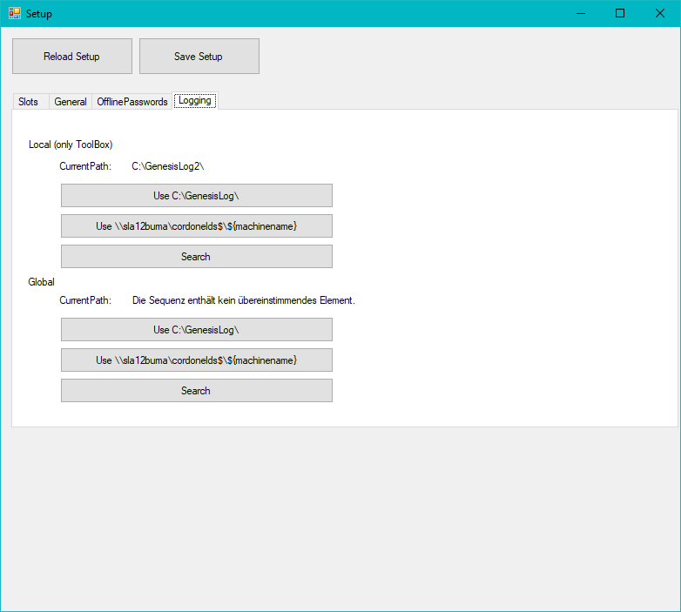
Figure 3.13 GTB Setup Logging Window

Troubleshooting

Licence Expired
The licence will be handled by a DB in Laatzen, Germany. Therefore it is essential to establish a VPN connection or be directly conncted to the SENSUS Laatzen network before EVERY new start of the GTB. Otherwise the licence cannot be obtained and the following window will pop up:
Figure 4.1 Licence Expired Message
The licence is linked to the version and has an expiration date. On new released SW this licence of an older version may be removed forcing the users to upate to the latest GTB.
Sometimes the initial start of the SW shows that window caused by a connection timeout even if this licence is valid. Therefore a second trial should be started.
On licence problems contact the SW developers.

Connection Problems
If the connection to the device fails, the “Setup” tool of the GTB [0 Setup] may help to check for proper settings. The “DetectRequest” checks the assignment of the IrDA serial port including a communication check. If this succeeds, the entire path including a valid response to the Cordonel™ has been vaidated.
Causes of failed analysis:
- Wrong assignment of serial ports (ports have to be identical to [2.5]),
- Wrong selection of protocol (IrdaRequest needed to be set),
- Adjustment of IrDA-Plug-In,
- Natural sun light or artifical light emmitting (cover the device very well),
- Disconnected cable,
- Disconnected power-plug of the Mini-MOXA.

Invalid Slot Selection
Selection of an invalid “Slot” in the FW-Update window will diplay:
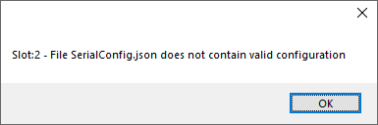
Figure 4.2 Invalid Slot Selection Window

Password Access
If the logon to the Cordonel™ fails, the password may not be accessable or assigned. For this reason call the SW developer.

Light Sensistivity
The IrDA interface is very sensistive against sunligth and other artificial light sources. Be aware to cover the entire Cordonel™ by boxing it.
This is the most observed reason for communication and therefore update problems.

Contacts
Name | Function | Mail
Alex Frost | FW Developer | Alex.Frost@xylem,com
Mark Clemens | FW Developer | Mark.Clemens@xylem.com
Roland Drabesch | SW Developer | Roland.Drabesch@xylem.com
Thomas Wiedebusch | SW Developer - external | thomas.wiedebusch@t-wiedebusch.de
Nikolas Orelly | IT Department | nicolas.orelly@xylem.com
Table 5.1 Contacts

